Anton Ortmeier, 1798; Ferdinand Ortmeier, 1834
3.5. Herman Ortmeier m. 01/09/1894 Clara Maly
May 25, 1868*July 21, 1926 Aug. 6, 1876*Jan. 18, 1930
Both are buried at St. Boniface Cemetery, Monterey, NE
4.1. Frances Ortmeier
May 10, 1895*Mar. 18, 1980
4.2. Mary Ortmeier
July 28, 1897*Nov. 6, 1983
4.3. Caroline Ortmeier
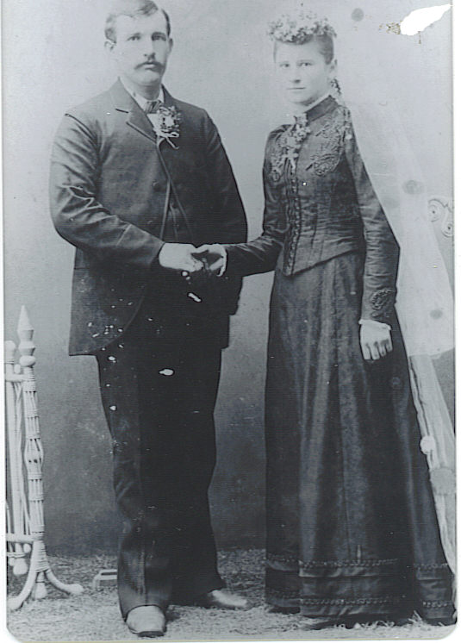
Aug. 8, 1899*Apr. 27, 1949
4.4. Catherine Ortmeier
Apr. 8, 1901*Oct. 10, 1979
4.5. Anna Theresa Ortmeier
Oct. 15, 1903*Mar. 25, 1987
4.6. Clara Mary Ortmeier
Feb. 8, 1906*Aug. 17, 1989
4.7. Theresa Antonia Ortmeier
July 5, 1908*Dec. 15, 2002
4.8. Wenzel Ferdinand Ortmeier
Apr. 29, 1910*May 20, 1973
4.9. Ida Mary Ortmeier
May 24, 1912*
4.10. Herman Ortmeier
Dec. 16, 1914*Dec. 16, 1914
4.11. John Herman Ortmeier
Feb. 28, 1916*May 26, 1992
4.12. Fritz Ortmeier
Nov. 12, 1917*Nov. 12, 1917 Herman & Clara Ortmeier, Jan. 9, 1894
4.13. Verna Mary Ortmeier
Nov. 18, 1918*Aug. 11, 2002
4.14. Hermina Ortmeier
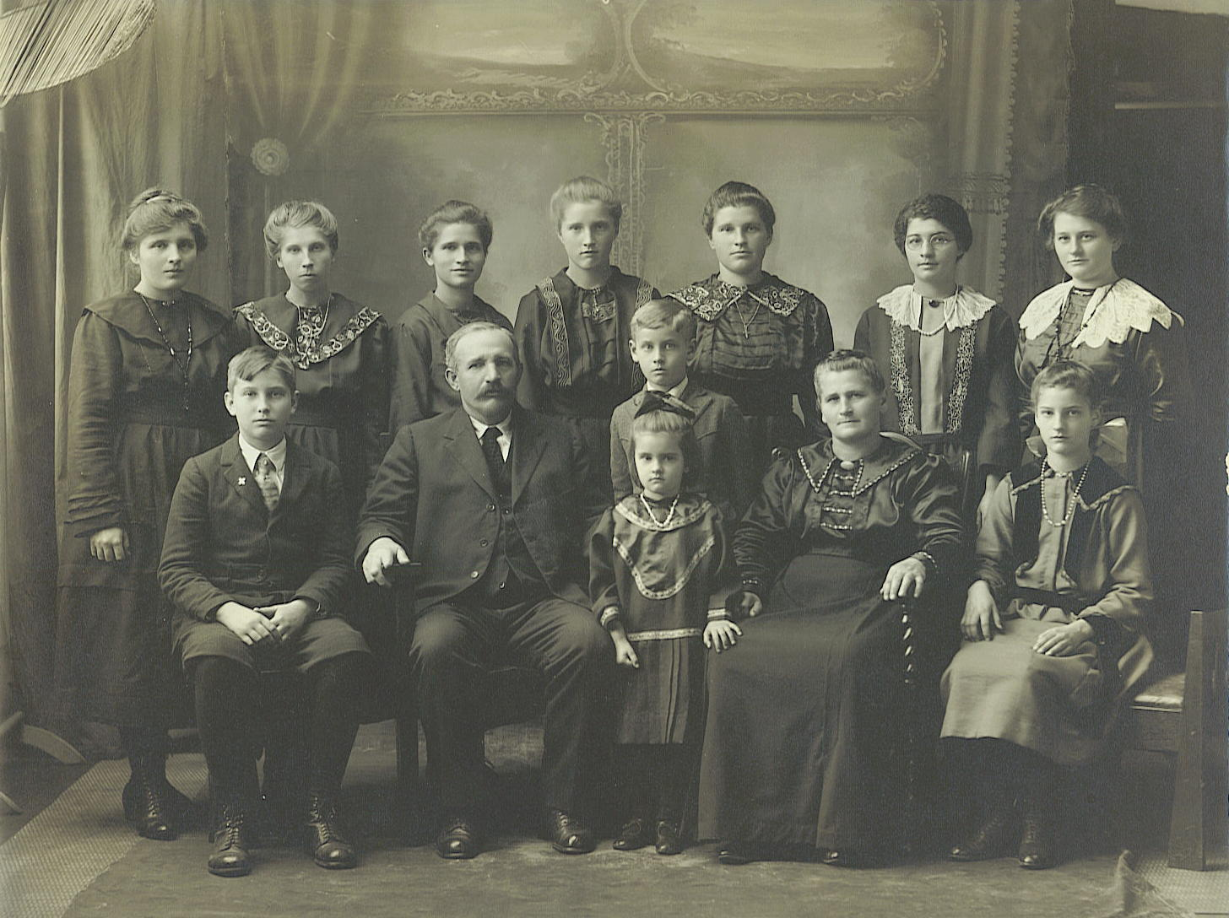
Apr. 20, 1922* Apr. 20, 1922

Katie, Clara, Mary, Theresa, Frances,
Anna, Caroline.
Wenzel, Herman Ortmeier, John,
Verna, Clara Maly Ortmeier, Ida
c. 1923

“He lost a finger, how did that happen?...Well, on the sewing machine, ach, circular saw and he got his finger too close and it was just dangling on when he came into the house and then George Franzluebbers right away took him to the doctor. He was there helping with the sawing; he took him to the doctor then and the doctor just sewed it up and sent him home.” – Theresa Ortmeier Huhman, 2002
TABLE OF CONTENTS

Herman / Clara Maly Ortmeier……………………………………………………….. 1
Frances Ortmeier Franzluebbers……..………………………………………………. 3

Mary Ortmeier Ulrich ………………………………………………………………... 16

Caroline Ortmeier Spenner……………………………………………………………19
Catherine Ortmeier Franzluebbers……...…………………………………………... 27

Anna Ortmeier Herrmann……………………………………………………………..35

Clara Ortmeier Monteforte…………………………………………………………... 36

Theresa Ortmeier Huhman……………………………………………………………44

Wenzel Ortmeier………………………………………………………………………..51

Ida Ortmeier Peatrowsky………………………………………………………………58

Herman Ortmeier……………………………………………………………………......1

John Ortmeier…………………………………………………………………………. 64
Fritz Ortmeier……………………………………………………………………………1
Verna Ortmeier Schneider……………………………………………………………..67

Hermina Ortmeier……………………………………………………………………….1

Cemeteries ……………………………………………………………………...Appendix

Frances Ortmeier and George Franzluebbers
________________________________________________________________________________________________________________________________________________
Anton Ortmeier, 1798; Ferdinand Ortmeier, 1834; 3.5 Herman Ortmeier, 1868
4.1. Frances F. Ortmeier m. 05/08/1918 George Franzluebbers
May 5, 1895* West Point, NE Feb. 9, 1884* Delbruck, Germany
Mar. 18, 1980 July 20, 1957
Both are buried at St. Boniface Cemetery, Monterey, NE
Occupations: Housewife Farmer
Interests: Gardening/crocheting Singing/playing cards
5.1. Herman Franzluebbers
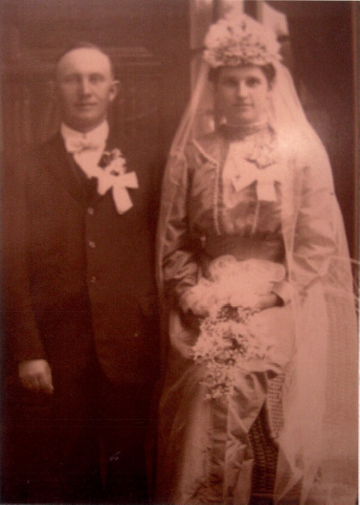
Aug. 1, 1919*Apr. 19, 2006
5.2. Bernard Franzluebbers
Aug. 1, 1921*Dec. 28, 2010
5.3. John Franzluebbers
Mar. 23, 1923*Sept. 10, 1976
5.4. Josephine Franzluebbers
Jan. 21, 1925*
5.5. Caroline Franzluebbers
Nov. 6, 1926*
5.6. Catherine Franzluebbers
Sept. 30, 1928*
5.7. Ann Marie Franzluebbers
Apr. 17, 1930*
5.8. Clara (Sr. Georgiana) Franzluebbers
Apr. 8, 1931*
5.9. Theresa (Sr. Frances) Franzluebbers George & Frances Franzluebbers
Sept. 24, 1933* May 8, 1918
5.10. Ferdinand Franzluebbers
Sept. 3, 1935*Sept. 3, 1935
5.11. Rose Marie Franzluebbers
Mar. 2, 1938*

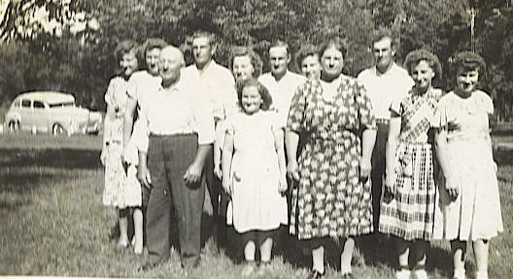

George & Frances Franzluebbers family, ca. 1948
_______________________________________________________________________
Anton Ortmeier, 1798; Ferdinand Ortmeier, 1834; 3.5 Herman Ortmeier, 1868;
4.1 Frances Ortmeier Franzluebbers, 1895
5.1. Herman Joseph Franzluebbers m. 06/05/1951 Catherine Ruskamp
Aug. 1, 1919* Monterey, NE Feb. 27, 1926* Cuming County, NE
Apr. 19, 2006 Mar. 28, 2001
Both are buried at Sacred Heart Cemetery, Olean, NE
6.1. Karen Franzluebbers
July 27, 1952*
6.2. Linda Franzluebbers
June 8, 1954*
6.3. Allan Franzluebbers
Aug. 22, 1955*
6.4. Daniel Franzluebbers
Nov. 15, 1956*
6.5. Marilyn Franzluebbers
May 15, 1959*
6.6. Doris Franzluebbers
Aug. 16, 1960*
6.7. Diane Franzluebbers
Aug. 29, 1963*
6.8. Duane Franzluebbers
Apr. 22, 1965*
6.9 Glen Franzluebbers
Oct. 26, 1968*
________________________________________________________________________
Anton Ortmeier, 1798; Ferdinand Ortmeier, 1834; 3.5 Herman Ortmeier, 1868;
4.1 Frances Ortmeier Franzluebbers, 1895; 5.1 Herman Franzluebbers, 1919
6.1. Karen Franzluebbers m. 06/28/1975 Jim Hunke
July 27, 1952* West Point, NE Mar. 9, 1949* West Point, NE
7.1. Brian James Hunke m.08/19/2006 Jacqueline Oeth
Sept. 2, 1980* North Platte, NE Aug. 13, 1984* Des Moines, IA
7.2. Kristin Marie Hunke m. 09/26/2009 Jacob Horky
Feb. 6, 1984* North Platte, NE Nov. 17, 1983* Metairie, LA
6.2. Linda Franzluebbers m. 07/05/1980 Jerold W. Tomsen
June 8, 1954* West Point, NE Nov. 22, 1948* Omaha, NE
7.1. Carly Tomsen
Oct. 1, 1980*
7.2. Christian Tomsen
Aug. 12, 1983*
7.3. Audra Tomsen
Dec. 9, 1986*
6.3. Allan Franzluebbers m. 08/13/1977 Bonnie Hassler
Aug. 22, 1955* West Point, NE Aug. 18, 1956* West Point, NE
7.1. Jeremy Allan Franzluebbers
July 27, 1979*
7.2. Ginny Lynn Franzluebbers
June 15, 1981*
7.3. Reggie Daniel Franzluebbers
Apr. 1, 1985*
7.4. Gary James Franzluebbers
Nov. 13, 1988*
7.5. Kaylie Franzluebbers
July 31, 1995*
7.6. Marci Franzluebbers
Nov. 10, 1998*
6.4. Daniel Franzluebbers
Nov. 15, 1956* West Point, NE
6.5. Marilyn Franzluebbers m. 09/14/1985 Glenn Moberg
May 15, 1959* West Point, NE Apr. 9, 1957* Westchester, IL
7.1. Molly Moberg
Dec. 6, 1990*
7.2. Libby Moberg
Oct. 12, 1995*
6.6. Doris Franzluebbers m. 11/07/1981 Randell B. Ortmeier
Aug. 16, 1960* West Point, NE Sept. 17, 1957* West Point, NE
7.1. Michelle Lynn Ortmeier
Oct. 4, 1983*
7.2. Brett Randall Ortmeier
Nov. 25, 1985*
7.3. Nicole Marie Ortmeier
Feb. 1, 1990*
6.7. Diane Franzluebbers m. 09/30/1988 Michael Cech
July 29, 1963* West Point, NE Dec. 22, 1962* Omaha, NE
6.8. Duane Franzluebbers m. 05/21/1988 Bonnie Coufal
Apr. 22, 1965* West Point, NE Nov. 22, 1966* West Point, NE
7.1. Laura M. Franzluebbers (adopted)
Nov. 30, 1995*
6.9. Glen Franzluebbers m. 08/24/2001 Kelly Nelson
Oct. 26, 1968* West Point, NE Jan. 15, 1964* Fremont, NE
________________________________________________________________________
Anton Ortmeier, 1798; Ferdinand Ortmeier, 1834; 3.5 Herman Ortmeier, 1868
4.1 Frances Ortmeier Franzluebbers, 1895
5.2. Bernard Franzluebbers m. 09/03/1952 Lillian Vogel
Aug. 17, 1921, Cuming County, NE*Dec. 28, 2010 Mar. 6, 1927*
Buried at Sacred Heart Cemetery, Olean, NE
6.1. Marlene Franzluebbers
Oct. 12, 1953*
6.2. David Franzluebbers
Dec. 3, 1954*
6.3. Richard Franzluebbers
Apr. 31, 1956*
6.4. Robert Franzluebbers
Aug. 11, 1957*
6.5. Rita Franzluebbers
Jan. 6, 1959*
6.6. Melvin Franzluebbers
Feb. 27, 1960*Feb. 27, 1979
6.7. Janice Franzluebbers
Dec. 7, 1961*
6.8. Donald Franzluebbers
Apr. 25, 1964*
_______________________________________________________________________Anton Ortmeier, 1798; Ferdinand Ortmeier, 1834; 3.5 Herman Ortmeier, 1868;
4.1 Frances Ortmeier Franzluebbers, 1895; 5.2 Bernard Franzluebbers, 1921
6.1. Marlene Franzluebbers m. 07/03/1976 Robert Rolf
Oct. 12, 1953* West Point, NE Sept. 30, 1951* West Point, NE
7.1. Jason Rolf m. 06/02/2007 Sara Knobbe
July 29, 1978* Fremont, NE Apr. 3, 1982*West Point, NE
8.1. Mason Robert Rolf
Aug. 11, 2010*
7.2. John Michael Rolf m. 07/05/2008 Mary Bogle-Smith
Mar. 28, 1980* West Point, NE May 17, 1980* Joplin, MO
7.3. Kara Rolf
Dec. 1, 1982* West Point, NE
6.2. David Franzluebbers m. 05/15/1976 LuAnn Schlickbernd
Dec. 3, 1954* West Point, NE Sept. 20, 1956* West Point, NE
7.1. Ryan David Franzluebbers
Dec. 13, 1979*
7.2. Jared Franzluebbers
Feb. 2, 1982*
7.3. Laura Franzluebbers
Sept. 17, 1987*
7.4. Kyle Franzluebbers
Oct. 24, 1993*
6.3. Richard Franzluebbers m. 06/18/1986 Marlyce Harms
Mar. 31, 1956* West Point, NE Mar. 21, 1961*
7.1. Eugene Franzluebbers
Oct. 20, 1988*
7.2. Kayla Franzluebbers
Aug. 9, 1990*
6.4. Robert Franzluebbers
Aug. 11, 1957*
6.5. Rita Franzluebbers m. 06/30/1979 Tim Hunke
Jan. 6, 1959* West Point, NE Feb. 12, 1956* West Point, NE
7.1. Brian Hunke
Mar. 22, 1982* West Point, NE

8.1. Quinton Hunke
Sept. 3, 2004*
7.2. Julie Hunke
Mar. 18, 1983* West Point, NE
7.3. Steven Hunke
Sept. 3, 1985* West Point, NE
7.4. Katie Hunke
Sept. 15, 1988*
6.6. Melvin Franzluebbers
Feb. 27, 1960, Dodge, NE*Feb. 27, 1979
Buried at Sacred Heart Cemetery, Olean, NE
6.7. Janice Franzluebbers m. 04/27/1985 Ronald Parolek
Dec. 7, 1961* West Point, NE Sept. 10, 1958* Schuyler, NE
7.1. Samantha Parolek
June 12, 1989*
7.2. Zachary Parolek
Aug. 8, 1992*
6.8. Donald Franzluebbers m. 07/02/1994 Lori Robison
Apr. 25, 1964* West Point, NE Nov. 5, 1968* Basset, NE
7.1. Emily Irene Franzluebbers
Jan. 6, 1997*
7.2. Elizabeth Franzluebbers
June 1, 1998*
7.3. Erin Franzluebbers
Dec. 23, 2002*
________________________________________________________________________
Anton Ortmeier, 1798; Ferdinand Ortmeier, 1834; 3.5 Herman Ortmeier, 1868
4.1 Frances Ortmeier Franzluebbers, 1895
5.3. John Franzluebbers m. 06/21/1951 Margaret Steffensmeier
Mar. 23, 1923* Olean, Cuming County, NE July 2, 1928* West Point, NE
Sept. 10, 1976; Buried at St. Boniface Cemetery, Monterey, NE
6.1. Kathleen Franzluebbers
Apr. 18, 1952*
6.2. Joan Franzluebbers
July 12, 1953*
6.3. Mary Kay Franzluebbers
Aug. 5, 1956*
6.4. James Franzluebbers
Sept. 15, 1960*
6.5. Eileen Franzluebbers
Mar. 15, 1965*
________________________________________________________________________
Anton Ortmeier, 1798; Ferdinand Ortmeier, 1834; 3.5 Herman Ortmeier, 1868;
4.1 Frances Ortmeier Franzluebbers, 1895; 5.3 John Franzluebbers, 1923
6.1. Kathleen Franzluebbers m. 11/10/1973 David Fox
Apr. 18, 1952* West Point, NE div. Dec. 6, 1952*
7.1. David Fox
Feb. 10, 1974*
7.2. Jennifer Lynn Fox
June 5, 1979*
(Kathleen) m. 07/07/1990 Gordon Yunker July 23, 1952* West Point, NE 7.3. Christopher Yunker
Jan. 4, 1973*
8.1. Alyssa Yunker
Feb. 1, 1999*
8.2. Hannah Yunker
July 23, 2001*
8.3. Ty Yunker
June 23, 2004*
7.4. Michelle Marquis
May 17, 1975*
8.1. Avery Marquis
Aug. 19, 2003*
8.2. Jack Marquis
Jan. 1, 2006*
8.3. Ben Marquis
May 2, 2007*
8.4. Hayden Marquis
June 22, 1020*
6.2. Joan Franzluebbers m. 07/07/1979 Stephen Kinnet
July 12, 1953* West Point, NE Jan. 13, 1949* Lincoln, NE
7.1. Ryan Douglas Kinnet
Nov. 7, 1980*
7.2. Eric John Kinnet
May 31, 1983*May 31, 1983
7.3. Derek James Kinnet
Aug. 28, 1985*
7.4. Corey John Kinnet
May 16, 1987*May 16, 1987
7.5. Tyler John Kinnet
May 14, 1991*May 25, 1991
The three babies are buried at St. Boniface Cemetery, Monterey, NE
6.3. Mary Kay Franzluebbers m. 05/31/1974 David Evert
Aug. 5, 1956* West Point, NE Nov. 6, 1953* West Point, NE
7.1. John Evert m. 10/01/2005 Stacey Duncan
Sept. 28, 1974*West Point, NE Red Oak, Ia
8.1. Grace Evert
8.2. Duncan Evert
7.2. Daniel Joseph Evert
Nov. 4, 1975*West Point, NE

7.3. Kristy Marie Evert m. 06/18/2002 Troy Ortmeier
Dec. 15, 1978* Jan. 17, 1968*
8.1. Hayley Ortmeier
Mar. 25, 2003*
8.2. Blake Ortmeier
May 15, 2004*
Stepchildren:
8.3. Brent Ortmeier
Jan. 7, 1987*
8.4. Shelby Ortmeier
July 25, 1991*
8.5. Jordan Ortmeier
June 12, 1994*
6.4. James G. Franzluebbers m. 06/12/1981 Carol A. Mestl
Sept. 15, 1960* West Point, NE Nov. 12, 1959* Omaha, NE
7.1. Nichole Marie m. 12/31/2004 Nate Ball
Oct. 30, 1981* Sept. 25, 1981*
8.1. Kelsey Ball
May 21, 2007*
8.2. Zachary Ball
Nov. 17, 2009*
7.2. Ashley Franzluebbers m. 07/19/2008 Josh Peterson
Aug. 13, 1983*
7.3. Adam James Franzluebbers
Dec. 10, 1984*
7.4. Jason Franzluebbers
Oct. 1, 1986*
7.5. Melissa Franzluebbers
Nov. 19, 1990*
7.6. Andrew John Edward Franzluebbers
Nov. 27, 2000*
6.5. Eileen Franzluebbers m. 07/12/1987 Kirk Parker
Mar. 15, 1965* West Point, NE July 13, 1962* North Platte, NE
7.1. Kody Andrew Parker
May 7, 1988*
7.2. Mitchell Parker
May 20, 1992*
________________________________________________________________________
Anton Ortmeier, 1798; Ferdinand Ortmeier, 1834; 3.5 Herman Ortmeier, 1868
4.1 Frances Ortmeier Franzluebbers, 1895
5.4. Josephine Franzluebbers m. 09/27/1949 Rudy Kampschnieder
Jan. 21, 1925* Cuming County, NE Oct. 20, 1917, Cuming County*Oct. 13, 1978.
Buried at Sacred Heart Cemetery, Olean, NE
6.1. Gerald Kampschnieder
July 27, 1950*
6.2. Mary Ann Kampschnieder
Jan. 12, 1952*
6.3. Paul Kampschnieder
Feb. 11, 1954*
6.4. JoAnn Kampschnieder
Sept. 25, 1957*
6.5. Irvin Kampschnieder
Aug. 19, 1961*
________________________________________________________________________
Anton Ortmeier, 1798; Ferdinand Ortmeier, 1834; 3.5 Herman Ortmeier, 1868;
4.1 Frances Ortmeier Franzluebbers, 1895; 5.4 Josephine Franzluebbers Kampschnieder, 1925
6.1. Gerald Kampschnieder m. 08/14/1976 Charlotte McMahan
July 27, 1950* West Point, NE div. Oct. 18, 1942*
7.1. Michelle Lynn Kampschnieder m. 09/27/1997 Adam Lee Griger
July 11, 1978*
8.1. Abigail Marie Griger
Nov. 25, 1995*
8.2. Molly Renee Griger
Dec. 9, 1999*
8.3. Nathanial Maximus Griger
May 17, 2001*
8.4. Zachary Addison Griger
Jan. 3, 2008*
8.5. Samuel Oliver Griger
Apr. 29, 2009*
(Gerald) m. 01/20/1997 Shirley Goertz
May 11, 1954* Schuyler, NE
6.2. Mary Ann Kampschnieder m. 02/14/1981 Kenneth R. Kelley
Jan. 12, 1952* West Point, NE June 7, 1948* Eldorado, AR
7.1. Beth Mariah Kelley m. 04/23/2005 Julian Dandini
Jan. 26, 1984*
8.1. Frankie Dandini
May 18, 2001*
8.2 Mariah Dandini
Dec. 28, 2003*
7.2. Melissa Kelley
Apr. 17, 1990*
6.3. Paul Kampschnieder m. 09/18/1984 Lois Burenheide
Feb. 11, 1954* West Point, NE Feb. 22, 1965* West Point, NE
7.1. Allen Kampschnieder
July 18, 1986*
7.2. Rick Kampschnieder
Sept. 8, 1987*
7.3. Matthew Kampschnieder
July 21, 1989*
7.4. Heather Kampschnieder
Jan. 16, 1992*
7.5. Haley Kampschnieder
Feb. 14, 1995*
6.4. JoAnn Kampschnieder m.05/25/1984 David Ferris
Sept. 25, 1957* West Point, NE June 4, 1955* Norfolk, NE
7.1. Kenny Ray Ferris
Oct. 7, 1980*
6.5. Irvin Kampschnieder m. 04/22/1989 Betty Ann Rolf
Aug. 19, 1961* West Point, NE Dec. 7, 1965* West Point, NE
7.1. Chelsea Kampschnieder
Sept. 22, 1991*
7.2. Logan Kampschnieder
Feb. 23, 1995*
________________________________________________________________________
Anton Ortmeier, 1798; Ferdinand Ortmeier, 1834; 3.5 Herman Ortmeier, 1868
4.1 Frances Ortmeier Franzluebbers, 1895
5.5. Caroline Franzluebbers m. 09/27/1949 Clarence Kampschnieder
Nov. 6, 1926* near Monterey, NE Dec. 31, 1920 near Olean*June 5, 2004
Buried at Sts Peter & Paul Cemetery, Howells, NE
6.1. Loren Kampschnieder
Nov. 30, 1950*
6.2. John R. Kampschnieder
Sept. 14, 1953*
6.3. Dorothy Kampschnieder
Sept. 12, 1955*
6.4. Betty Kampschnieder
Oct. 15, 1956*
6.5. Theresa Kampschnieder
May 20, 1959*
6.6. Ann Kampschnieder
Feb. 24, 1962*
6.7. Joseph Kampschnieder
June 1, 1963*
6.8. Elaine Kampschnieder
Jan. 20, 1965*
6.9. Marie Kampschnieder
Nov. 17, 1966*
________________________________________________________________________
Anton Ortmeier, 1798; Ferdinand Ortmeier, 1834; 3.5 Herman Ortmeier, 1868;
4.1 Frances Ortmeier Franzluebbers, 1895; 5.5 Caroline Franzluebbers Kampschnieder, 1926
6.1. Loren Kampschnieder m. 07/09/1983 Deborah Ann Terhune
Nov. 30, 1950* West Point, NE Apr. 7, 1956* Fairfax, MO
7.1. Lorellee Kampschnieder
July 11, 1994*
6.2. John R. Kampschnieder m. 05/06/1978 Betty Bayer
Sept. 14, 1953* West Point, NE Mar. 17, 1956* West Point, NE
7.1. Angela Kampschnieder
May 22, 1985*
7.2. Michael Kampschnieder
July 18, 1988*
6.3. Dorothy Kampschnieder m. 09/26/1987 Paul Virgl
Sept. 12, 1955* West Point, NE Feb. 22, 1956* Wahoo, NE
7.1. Laura Virgl
Nov. 18, 1993*
6.4. Betty Kampschnieder m. 04/28/1988 Steve Nelson
Oct. 15, 1956* West Point, NE Oct. 29, 1958* Lincoln, NE
7.1. Kari Nelson
July 31, 1994*
6.5. Theresa Kampschnieder m. 02/13/1988 Charles F. Uher
May 20, 1959* West Point, NE Aug. 6, 1961*
7.1. Eric Uher
May 14, 1990*
7.2. Jenna Uher
Sept. 28, 1992*
6.6. Ann Kampschnieder m. 07/11/1987 William Jansky
Feb. 24, 1962* West Point, NE July 7, 1965* Geneva, NE
7.1. Brent Jansky
Mar. 2, 1989*
7.2. Darin Jansky
Jan. 4, 1992*
6.7. Joseph Kampschnieder m. 09/08/1990 Mary Jo Ruskamp
June 1, 1963* West Point, NE Aug. 14, 1966* West Point, NE
7.1. Jessica Kampschnieder
Feb. 16, 1991*
7.2. Mitchell Kampschnieder
Feb. 4, 1995*
6.8. Elaine Kampschnieder m. 04/08/1989 Steve Rodenbaugh
Jan. 22, 1965* West Point, NE Dec. 10, 1959* Alma, NE
7.1. Bryan Rodenbaugh
May 27, 1992*
7.2. Kristin Leigh Rodenbaugh
Feb. 2, 1995*
6.9. Marie Kampschnieder m. 07/25/1998 Bill Sander
Nov. 17, 1966* West Point, NE Sept. 25, 1968* Omaha, NE
7.1. Kayleigh Marie Sander
Aug. 1, 2002*
7.2. Allison Renae Sander
Mar. 21, 2004*

________________________________________________________________________
Anton Ortmeier, 1798; Ferdinand Ortmeier, 1834; 3.5 Herman Ortmeier, 1868
4.1 Frances Ortmeier Franzluebbers, 1895
5.6. Catherine Franzluebbers
Sept. 30, 1928* in West Point, NE
________________________________________________________________________
Anton Ortmeier, 1798; Ferdinand Ortmeier, 1834; 3.5 Herman Ortmeier, 1868;
4.1 Frances Ortmeier Franzluebbers, 1895
5.7. Ann Marie Franzluebbers m. 08/20/1957 Wilfred Steffensmeier
Apr. 17, 1930* West Point, NE Oct. 24, 1927 West Point, NE*Jan. 4, 2002
Buried at Sts Peter & Paul Cemetery, Howells, NE
6.1. Loretta Steffensmeier
Sept. 23, 1958*
6.2. Arlene Steffensmeier
Oct. 8, 1959*
6.3. Marjorie Steffensmeier
Feb. 28, 1961*
6.4. Patrick Steffensmeier
May 15, 1964*
6.5. Carol Steffensmeier
Dec. 5, 1965*
6.6. Steven Steffensmeier
May 22, 1970*
________________________________________________________________________
Anton Ortmeier, 1798; Ferdinand Ortmeier, 1834; 3.5 Herman Ortmeier, 1868;
4.1 Frances Ortmeier Franzluebbers, 1895; 5.7 Anne Marie Franzluebbers Steffensmeier, 1930
6.1. Loretta Steffensmeier m. 01/21/2000 Larry Hockemeier
Sept. 23, 1958* West Point, NE Apr. 9, 1956* Tilden, NE
6.2. Arlene Steffensmeier
Oct. 8, 1959* West Point, NE
6.3. Marjorie Steffensmeier m. 06/27/1981 Randy Cech
Feb. 28, 1961* West Point, NE Apr. 10, 1961* Schuyler, NE
7.1. Becky Ann Cech m. 07/09/2005 Jason Schueth
Apr. 11, 1983*
8.1. Clay Wayne Schueth
June 24, 2010*
7.2. Amy Cech m. Joe Hoferer
Feb. 18, 1986*

7.3. Keith Cech
Mar. 26, 1989*
6.4. Patrick Steffensmeier m. 06/25/1988 Mary Pieper
May 15, 1964* West Point, NE Feb. 28, 1966* Schuyler, NE
7.1. Michael Patrick Steffensmeier
July 13, 1991*
7.2. Lisa Steffensmeier
Apr. 27, 1994*
6.5. Carol Steffensmeier m. 08/05/2000 David Semerad
Dec. 5, 1965* West Point, NE Mar. 15, 1967*
6.6. Steven Steffensmeier
May 22, 1970* West Point, NE
________________________________________________________________________
Anton Ortmeier, 1798; Ferdinand Ortmeier, 1834; 3.5 Herman Ortmeier, 1868
4.1 Frances Ortmeier Franzluebbers, 1895
5.8. Sister M. Georgiana Franzluebbers (Clara)
Apr. 8, 1931* West Point, NE
________________________________________________________________________
Anton Ortmeier, 1798; Ferdinand Ortmeier, 1834; 3.5 Herman Ortmeier, 1868
4.1 Frances Ortmeier Franzluebbers, 1895
5.9. Sister M. Frances Franzluebbers (Theresa)
Sept. 24, 1933* West Point, NE
________________________________________________________________________
Anton Ortmeier, 1798; Ferdinand Ortmeier, 1834; 3.5 Herman Ortmeier, 1868;
4.1 Frances Ortmeier Franzluebbers, 1895
5.11. Rose Marie Franzluebbers m. 06/11/1958 Ignatius Gentrup
Mar. 2, 1938* West Point, NE May 18, 1931 Beemer, NE*Dec. 19, 1992
Buried at St. Michael’s Cemetery, West Point, NE
6.1. Christine Gentrup
July 7, 1959*
6.2. Ronald Gentrup
Jan. 8, 1961*
6.3. Marvin Gentrup
Apr. 4, 1962*
6.4. Leon Gentrup
Mar. 6, 1963*
6.5. Joseph Gentrup
Apr. 10, 1964*Apr. 10, 1964
6.6. Jean Gentrup
Mar. 1 1967*
6.7. Lynn John Gentrup
July 11, 1968*
________________________________________________________________________
Anton Ortmeier, 1798; Ferdinand Ortmeier, 1834; 3.5 Herman Ortmeier, 1868;
4.1 Frances Ortmeier Franzluebbers, 1895; 5.11 Rose Marie Franzluebbers Gentrup, 1938
6.1. Christine Gentrup m. 01/28/1995 Michael A. Coday, Jr.
July 9, 1959* West Point, NE Dec. 9, 1959* Atkinson, NE
7.1. Abigail Coday
Jan. 23, 1997*
6.2. Ronald Gentrup m. 10/27/1984 Diane Grovijohn
Jan. 8, 1961* West Point, NE Oct. 20, 1961* West Point, NE
7.1. Eric Daniel Gentrup
Oct. 2, 1985*Oct. 4, 1985
7.2. Ashley Marie Gentrup
Mar. 8, 1987*
7.3. Luke Joseph Gentrup
Jan. 25, 1989*
7.4. Kelly Lynn Gentrup
Feb. 24, 1992*
6.3. Marvin Gentrup m. 08/04/2006 Eileen Smith
Apr. 4, 1962* West Point, NE May 4, 1953* Albion, NE
Stepchildren:
7.1. Mitchell Smith
Oct. 5, 1979*
7.2. Rik Smith
Nov. 14, 1981*
6.4. Leon Gentrup m. 04/28/1990 Elizabeth Lynn Crain
Mar. 6, 1963* West Point, NE May 8, 1957* Sioux City, IA
7.1. Matthew Leon Gentrup
Jan. 25, 1991*
7.2. Daira Elizabeth Gentrup
Jan. 13, 1993*
6.5. Joseph Gentrup
Apr. 10, 1964*Apr. 10, 1964
Buried at St. Michael’s Cemetery, West Point, NE
6.6. Jean Gentrup m. 11/21/1987 Gary Lee Schulzkump
Mar. 1, 1967* West Point, NE Sept. 13, 1963* Oakland, NE
7.1. Andrew Schulzkump
Aug. 14, 1988*
7.2. Jacob Schulzkump
Apr. 4, 1990*
7.3. Nicki Schulzkump
Oct. 16, 1992*
6.7. Lynn John Gentrup
July 11, 1968* West Point, NE

Mary Ann Ortmeier and Louis Ulrich
________________________________________________________________________
________________________________________________________________________
Anton Ortmeier, 1798; Ferdinand Ortmeier, 1834; 3.5 Herman Ortmeier, 1868
4.2. Mary Ann Ortmeier m. 02/11/1920 Louis Ulrich
July 28, 1897, West Point, NE*Nov. 6, 1983 Sept. 12, 1891*Dec. 14, 1968
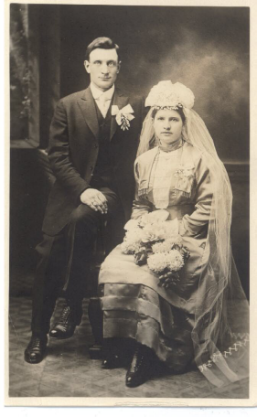
Both are buried at St. Michael’s Cemetery, West Point, NE
Occupations: Homemaker; Dairy employee
5.1. Clara Ulrich
Nov. 9, 1920*
5.2. Helen Ulrich
Sept. 13, 1922*
5.3. Ray Ulrich
July 6, 1924*May 5, 1984
5.4. Angie Ulrich
May 1, 1926*Sept. 22, 2010
5.5. Delores Ulrich Louis & Mary Ulrich
Sept. 10, 1929* Feb. 11, 1920

________________________________________________________________________
Anton Ortmeier, 1798; Ferdinand Ortmeier, 1834; 3.5 Herman Ortmeier, 1868;
4.2 Mary Ann Ortmeier Ulrich, 1897
5.1. Clara Ulrich m. 02/14/1939 Leo Grovijohn
Nov. 9, 1920* Apr. 18, 1916*Feb. 6, 1998
Buried at St. Anthony’s Cemetery, St. Charles, NE
6.1. James Grovijohn
Jan. 21, 1945*
6.2. Kathy Grovijohn
Mar. 2, 1952*
________________________________________________________________________
Anton Ortmeier, 1798; Ferdinand Ortmeier, 1834; 3.5 Herman Ortmeier, 1868;
4.2 Mary Ann Ortmeier Ulrich, 1897; 5.1 Clara Ulrich Grovijohn, 1920
6.1. James Grovijohn m. 04/11/1964 Nancy Rief
Jan. 21, 1945* Apr. 19, 1945*
7.1. Brian Grovijohn
Sept. 22, 1964*
7.2. Brenda Grovijohn
June 3, 1967*
7.3. Brad Grovijohn
June 7, 1971*
6.2. Kathy Grovijohn m.06/12/1976 Mark Larson
Mar. 2, 1952*
7.1. Nick Larson
Feb. 23, 1982*
7.2. Kellie Marie Larson
Nov. 14, 1984*
________________________________________________________________________
Anton Ortmeier, 1798; Ferdinand Ortmeier, 1834; 3.5 Herman Ortmeier, 1868;
4.2 Mary Ann Ortmeier Ulrich, 1897
5.2. Helen Ulrich m. James Richmond
Sept. 13, 1922*Dec. 4, 2004
________________________________________________________________________
Anton Ortmeier, 1798; Ferdinand Ortmeier, 1834; 3.5 Herman Ortmeier, 1868;
4.2 Mary Ann Ortmeier Ulrich, 1897
5.3. Raymond Ulrich m. 09/05/1948 Blanch Rougny
July 6, 1924, West Point, NE*May 5, 1984 May 10, 1929* Clovis, CA 6.1. Deborah Ulrich
July 12, 1952*
6.2. Cynthia Ulrich
Sept. 26, 1953*
6.3. Jan Ulrich
Aug. 12, 1955*
6.4. Brent Ulrich
Oct. 25, 1956*
6.5. Jeffrey Ulrich
Nov. 3, 1958*
________________________________________________________________________
Anton Ortmeier, 1798; Ferdinand Ortmeier, 1834; 3.5 Herman Ortmeier, 1868;
4.2 Mary Ann Ortmeier Ulrich, 1897; 5.3 Raymond Ulrich, 1924
6.1. Deborah Ulrich m. David Dupree
July 12, 1952* Clovis, CA Sept. 16, 1954* Kansas City, KS
7.1. Dalton Dupree
June 3, 1990*
6.2. Cynthia Ulrich m. 09/13/1971 Michael Leach
Sept. 26, 1953* Clovis, CA May 8, 1951*
7.1. Jennifer Leach
Oct. 30, 1973*
6.3. Jan Ulrich m. 03/03/1979 Steve Nixon
Aug. 12, 1955* Clovis, CA
(Jan) m. Jack Poisall
May 14, 1956* Clovis, CA
7.1. Taylor Poisall
Apr. 13, 1993*
7.2. Logan Poisall
Nov. 25, 1994*
6.4. Brent Ulrich m.07/23/1977 Debra Ann Betch
Oct. 25, 1956* June 2, 1954*
7.1. Jill Marie Ulrich
July 20, 1978*
6.5. Jeffrey Ulrich
Nov. 3, 1958*

________________________________________________________________________
Anton Ortmeier, 1798; Ferdinand Ortmeier, 1834; 3.5 Herman Ortmeier, 1868;
4.2 Mary Ann Ortmeier Ulrich, 1897
5.4. Angie Ulrich m. 06/18/1951 Bob Breetzke
May 1, 1926 West Point, NE*Sept. 22, 2010 Aug. 20, 1925* Beemer, NE
Cremated.
6.1. David Breetzke
Feb. 23, 1957*
6.2. Mary Breetzke
Apr. 12, 1959*
________________________________________________________________________
Anton Ortmeier, 1798; Ferdinand Ortmeier, 1834; 3.5 Herman Ortmeier, 1868;
4.2 Mary Ann Ortmeier Ulrich, 1897; 5.4 Angie Ulrich Breetzke, 1926
6.1. David Breetzke m. Ann
Feb. 23, 1957*
7.1. Michael Breetzke
6.2. Mary Breetzke m Brad Augustin
Apr. 12, 1959* Mar. 30, 1957* Hastings, NE
7.1. Eric Augustin
July 15, 1980*
7.2. Trevor Augustin
Feb. 10, 1992*
7.3. Natalie Augustin
Nov. 10, 1993*
________________________________________________________________________
Anton Ortmeier, 1798; Ferdinand Ortmeier, 1834; 3.5 Herman Ortmeier, 1868;
4.2 Mary Ann Ortmeier Ulrich, 1897
5.5. Delores Ulrich m. 04/13/1964 Bill Mitchell
Sept. 10, 1929* May 21, 1919*
(Delores) m ( ? Lewis)

Caroline Ortmeier and Carl Spenner
________________________________________________________________________
________________________________________________________________________
Anton Ortmeier, 1798; Ferdinand Ortmeier, 1834; 3.5 Herman Ortmeier, 1868
4.3. Caroline Ortmeier m. 10/07/1925 Carl Spenner
Aug. 8, 1899* West Point, NE July 6, 1895* West Point, NE
Apr. 26, 1949 June 15, 1952
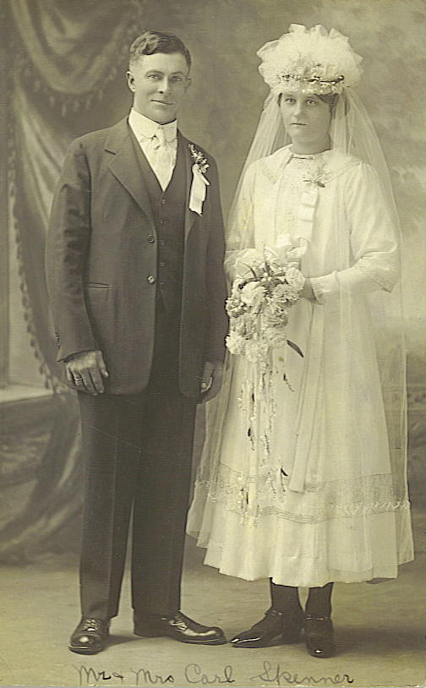
Both are buried at Holy Cross Cemetery, Beemer, NE
Occupations: Homemaker; Sewing/gardening Farmer
“Caroline, she was the one that played the organ and she never learned either she just played you know…we’d sing together a lot…”-Theresa Ortmeier Huhman, 2002
5.1. Clara Spenner
Feb. 27, 1927* Caroline & Carl Spenner
5.2. Gertrude Spenner Oct. 7, 1925
Oct, 5, 1928*Dec. 9, 2010
5.3. Frances Spenner
Jan. 7, 1930*
5.4. Martha Spenner
Aug. 31, 1931*
5.5. Bernadine Spenner
1933*1933
5.6. Arthur Spenner
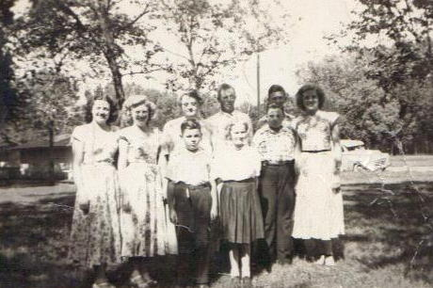
Oct. 26, 1934*
5.7. Gilbert Spenner
Dec. 18, 1936*
5.8. Mary Spenner
Mar. 22, 1938*
5.9. Bernard Spenner
Apr. 9, 1939*
5.10. Anton Spenner
1942*1942

Spenner family, ca. 1948

______________________________________________________________________
Anton Ortmeier, 1798; Ferdinand Ortmeier, 1834; 3.5 Herman Ortmeier, 1868;
4.3 Caroline Ortmeier Spenner, 1899
5.1. Clara Spenner m. 10/01/1946 Edmund Kluthe
Feb. 27, 1927* Beemer, NE May 20, 1921* Dodge, NE
6.1. Michael Carl Kluthe
Sept. 5, 1947*
6.2. Patricia Ann Kluthe
June 26, 1949*

________________________________________________________________________
Anton Ortmeier, 1798; Ferdinand Ortmeier, 1834; 3.5 Herman Ortmeier, 1868;
4.3 Caroline Ortmeier Spenner, 1899; 5.1 Clara Spenner Kluthe, 1927
6.1. Michael Carl Kluthe m. 12/16/1970 Ann Jeanettte Wynn
Sept. 5, 1947* West Point, NE Sept. 12, 1948* Austin, TX
7.1. Hannah Kluthe m. Matthew Moore
Apr. 20, 1973* Fort Hood, TX July 3, 1974* Philadelphia, PA
8.1. Gabriela Moore
Jan. 24, 2004*
8.2. Lydia Moore
Jan 24, 2004*
8.3. Samuel Moore
May 6, 2007*
8.4. Daniel Moore
May 6, 2007*
7.2. Rebekah Kluthe
Oct. 9, 1974* Hot Springs, SD
7.3. Joshua Kluthe
Feb. 10, 1978*
6.2. Patricia Ann Kluthe m. 06/20/1969 Joseph Hoyt Sutton
m. at Offutt Air Base, Omaha, NE
June 26, 1949* Dodge, NE Sept. 25, 1948* Atlanta, GA
7.1. Kristina Sutton m. 05/21/1994 Tobin Dobler
m. at Lake Tahoe
Jan. 12, 1970* Nuremburg, Germany Sept. 17, 1969* Lodi, CA
8.1. Cierra Dobler
Dec. 10, 1998*
8.2. Canyon Dobler
Aug. 16, 2001*
________________________________________________________________________
Anton Ortmeier, 1798; Ferdinand Ortmeier, 1834; 3.5 Herman Ortmeier, 1868;
4.3 Caroline Ortmeier Spenner, 1899
5.2. Gertrude Spenner m. 09/27/1953 James Beard
Oct. 5, 1928, Beemer, NE*Dec. 9, 2010 Oct. 1, 1925, Lincoln, NE*Aug. 12, 2004
Both are buried at Lincoln Memorial Park, Lincoln, NE (Calvary Catholic)
6.1. Elizabeth Beard
Mar. 19, 1956*
6.2. Susan Beard
Mar. 25, 1960*
________________________________________________________________________
Anton Ortmeier, 1798; Ferdinand Ortmeier, 1834; 3.5 Herman Ortmeier, 1868;
4.3 Caroline Ortmeier Spenner, 1899; 5.2 Gertrude Spenner Beard, 1928
6.1. Elizabeth Beard m. 08/18/1979 Daniel Nelson
Mar. 19, 1956* Lincoln, NE May 24, 1952* Lincoln, NE
7.1. Dylan G. Nelson
Oct. 23, 1990*
7.2. Wyatt J. Nelson
Apr. 21, 1994*
6.2. Susan Beard m. 07/31/1982 Rick Lange
Mar. 25, 1960* Lincoln, NE July 31, 1959* Lincoln, NE
7.1. Elizabeth M. Lange
May 11, 1986*
7.2. James D. Lange
Dec. 28, 1987*
7.3. Katharine Lange
Aug. 31, 1990*
________________________________________________________________________
Anton Ortmeier, 1798; Ferdinand Ortmeier, 1834; 3.5 Herman Ortmeier, 1868;
4.3 Caroline Ortmeier Spenner, 1899
5.3. Frances Spenner m. 12/19/1951 Robert Van Buskirk
Jan. 7, 1930* Beemer, NE Apr. 28, 1926 Cortland, NE*Jan. 7, 2006
Buried at Riverside National Cemetery, Riverside, CA
6.1. Kathleen Van Buskirk
Aug. 11, 1954*
6.2. Dianne Van Buskirk
Sept. 21, 1955*
6.3. Linda Van Buskirk
Apr. 15, 1959*
________________________________________________________________________
Anton Ortmeier, 1798; Ferdinand Ortmeier, 1834; 3.5 Herman Ortmeier, 1868;
4.3 Caroline Ortmeier Spenner, 1899; 5.3 Frances Spenner Van Buskirk, 1930
6.1. Kathleen Van Buskirk m. 07/26/1975 Wilke Smith
Aug. 11, 1954* Lincoln, NE July 10, 1954* Los Angeles, CA
7.1. Kristin Smith
June 22, 1980*
7.2. Lauren Smith
Feb. 21, 1983*
7.3. Kelli Smith
Dec. 25, 1984*
6.2. Dianne Van Buskirk m.03/05/1988 Jens Aarnaes
Sept. 21, 1955* Lincoln, NE June 12, 1957* Sherman Oaks, CA

6.3. Linda Van Buskirk m.04/15/1989 Mark Bigbee
Apr. 15, 1959* Canoga Park, CA Sept. l8, 1959 Dallas, TX*Sept. 1, 2009
________________________________________________________________________
Anton Ortmeier, 1798; Ferdinand Ortmeier, 1834; 3.5 Herman Ortmeier, 1868;
4.3 Caroline Ortmeier Spenner, 1899
5.4. Martha Spenner m. 06/27/1950 Alfred Kluthe
Aug. 31, 1931* Beemer, NE Oct. 10, 1924* Dodge, NE
Nov. 18, 1988
Buried at Mt. Hope Cemetery, Scotia, NE

6.1. Donald Kluthe
Aug. 16, 1951*
6.2. John Kluthe
Mar. 14, 1955*
6.3. Dale Kluthe
Nov. 24, 1954*
6.4. Ann Kluthe
July 30, 1960*
________________________________________________________________________
Anton Ortmeier, 1798; Ferdinand Ortmeier, 1834; 3.5 Herman Ortmeier, 1868;
4.3 Caroline Ortmeier Spenner, 1899; 5.4 Martha Spenner Kluthe, 1931
6.1. Donald Kluthe m. 04/02/1972
Aug. 16, 1951*
6.2. John Kluthe m. 08/01/1987 Deborah Hughes
Mar. 14, 1955* Ord, NE Apr. 16, 1958* Ainsworth, NE
7.1. Christopher Thomas Kluthe
Sept. 4, 1989*Apr. 4, 2005
7.2. Dana Kluthe
Mar. 3, 1991*
6.3. Dale Kluthe m. Kathy McDermott
Nov. 24, 1954*
7.1. David Alfred Kluthe
Jan. 13, 1990*
6.4. Ann Kluthe m. James Holmberg
July 30, 1960* Ord, NE
________________________________________________________________________
Anton Ortmeier, 1798; Ferdinand Ortmeier, 1834; 3.5 Herman Ortmeier, 1868;
4.3 Caroline Ortmeier Spenner, 1899
5.5. Arthur Spenner m. 12/13/1956 Maria Grasso
Oct. 26, 1934* Beemer, NE July 19, 1920* Procida, Italy
Dec. 28, 1991
Buried at St. Bonaventure Cemetery, Columbus, NE
6.1. Carl Spenner
Nov. 15, 1957*
6.2. Anne Marie Spenner
Dec. 20, 1958*
6.3. Patricia Spenner
June 25, 1960*
6.4. Anthony Spenner
Aug. 21, 1961* Apr. 21, 2009
6.5. Margaret Spenner
Aug. 30, 1964*
6.6. Joseph Spenner
Mar. 19, 1967*

________________________________________________________________________
Anton Ortmeier, 1798; Ferdinand Ortmeier, 1834; 3.5 Herman Ortmeier, 1868;
4.3 Caroline Ortmeier Spenner, 1899; 5.5 Arthur Spenner, 1934
6.1. Carl Spenner m. 06/29/1991 Delores Korcek
Nov. 15, 1957* Naples, Italy
(Carl) m. Deb Cerry
Nov. 28, 1960* Wahoo, NE
7.1. Brooke Spenner
Jan. 26, 1981*
7.2. Chelsea Spenner
Sept. 17, 1992*
7.3. Elliot Joseph Spenner
July 7, 1995*
7.4. Phillip Michael Spenner
May 20, 1997*
6.2. Anne Marie Spenner m. 06/23/1989 George Fearn III
Dec. 20, 1958* West Point, NE
(Anne) m. Keith Hastings
Apr. 28, 1962* Mesa, AZ 7.1. Kaemon Hastings
July 22, 1997*
7.2. Karson Hastings
Mar. 19, 2000*
6.3. Patricia Spenner m. Scott Baker
June 25, 1960* Howells, NE Aug. 28, 1960* Oklahoma, OK
7.1. Laureen Baker
Sept. 22, 1993*
7.2. Kristen Baker
Aug. 9, 1995*
6.4. Anthony Spenner m. 04/21/1990 Cathy Yum
Aug. 21, 1961* Columbus, NE June 16, 1964* Taejon, S. Korea
Apr. 21, 2009 Cremated
6.5. Margaret Spenner m. Matthew Minchow
Aug. 30, 1964* Jacksonville, FL Feb. 22, 1960* Lincoln, NE
7.1. Noel Minchow
Dec. 19, 1991*
7.2. Nathan Minchow
Sept. 17, 1996*
7.3. Olivia Minchow
Nov. 8, 1999*
6.6. Joseph Spenner
Mar. 19, 1967* Columbus, NE

________________________________________________________________________
Anton Ortmeier, 1798; Ferdinand Ortmeier, 1834; 3.5 Herman Ortmeier, 1868;
4.3 Caroline Ortmeier Spenner, 1899
5.6. Gilbert Spenner m. 08/06/1956 Benilda
Dec. 18, 1935* Beemer, NE Feb. 24, 1941* Howells, NE
6.1. Gary Alan Spenner
Oct. 18, 1959*
6.2. Cynthia M. Spenner
Jan. 25, 1961*
6.3. Dennis Spenner
Feb. 19, 1962*
6.4. Sheryl L. Spenner
Apr. 19, 1966*
________________________________________________________________________
Anton Ortmeier, 1798; Ferdinand Ortmeier, 1834; 3.5 Herman Ortmeier, 1868;
4.3 Caroline Ortmeier Spenner, 1899; 5.6 Gilbert Spenner, 1935
6.1. Gary Alan Spenner m. 09/12/1986 Marilyn Jean Jaroska
Oct. 18, 1959* West Point, NE Mar. 4, 1963* Norfolk, NE
6.2. Cynthia M. Spenner
Jan. 25, 1961* West Point, NE
6.3. Dennis Spenner m. Shelly
Feb. 19, 1962* West Point, NE July 4, 1962* Omaha, NE
6.4. Sheryl L. Spenner m. 08/05/1989 David Nevotti
Apr. 19, 1966* Fremont, NE Oct. 11, 1963* Omaha, NE
7.1. Jeremy David Nevotti
Jan. 20, 1990*
7.2. Jessica Loree Nevotti
May 10, 1993*
7.3. Joshua Andrew Nevotti
Aug. 19, 1995*
________________________________________________________________________
Anton Ortmeier, 1798; Ferdinand Ortmeier, 1834; 3.5 Herman Ortmeier, 1868;
4.3 Caroline Ortmeier Spenner, 1899
5.7. Mary Jane Spenner m. 04/27/1957 Clarence Schweitzer
Mar. 22, 1938* May 20, 1936*Mar. 15, 2002
6.1. Ed Schweitzer
May 4, 1957*
6.2. Betsy Schweitzer
Dec. 9, 1958*
6.3 Chuck Schweitzer
Feb. 12, 1960*
6.4. Marten Schweitzer
Mar. 3, 1961*
6.5. Caroline A. Schweitzer
May 7, 1962*

6.6. Rose Ann Schweitzer
June 6, 1963*
6.7. Marianne Schweitzer
Oct. 24, 1964*
6.8. Christine Schweitzer
Jan. 24, 1968*
________________________________________________________________________
Anton Ortmeier, 1798; Ferdinand Ortmeier, 1834; 3.5 Herman Ortmeier, 1868;
4.3 Caroline Ortmeier Spenner, 1899; 5.7 Mary Spenner Schweitzer, 1938
6.1. Ed Schweitzer m. Dawn Faye
May 4, 1957*Lincoln, NE
7.1. Crystal Schweitzer
7.2. Dustin Schweitzer
6.2. Betsy Schweitzer m. 04/12/1980-div Darrel Lindholm
Dec. 13, 1958*Lincoln, NE Jan. 7, 1955*
7.1. Matthew Lee Lindholm
Aug. 18, 1981*Lincoln, NE
7.2. Michelle Lindholm
Dec. 23, 1984*Lincoln, NE
7.3 Andy Lindholm
Nov. 25, 1986*Lincoln, NE
6.3 Chuck Schweitzer m.03/04/1981 Lori McIntosh
Feb. 12, 1960* Mar. 31, 1961*
(Chuck) Virginia Payne 7.1. Sydney Schweitzer
7.2. Cody Schweitzer
6.4. Martin Schweitzer m. 12/12/1985 – div. April Hawley
Mar. 3, 1961*
7.1. Martin J. (Jake) Schweitzer
Nov. 24, 1984?*
6.5. Caroline A. Schweitzer m.04/13/1991 Richard C. O’Leary
May 7, 1962* Lincoln, NE July 6, 1950* Des Moines, IA
7.1. Scott Nicholas O’Leary
Oct. 4, 1994*
6.6. Roseanne Schweitzer m.06/22/2001 Ken Scurto
June 6, 1963*
7.1. Bret Desh
7.2. Samantha Desh
6.7. Marianne Schweitzer m. Jeff Eckman
Oct. 24, 1964*
6.8. Christine Schweitzer m.09/24/2005 Clint Dittmar
Jan. 24, 1968*
7.1. Alana Dittmar m.06/26/2009 Mike Seeman
Feb. 3, 1982*
7.2. Kielen Dittmar
Jan. 6, 1989*
7.3. Tanna Dittmar
Feb. 24, 1990*
7.4. Jocelyn Dittmar
Feb. 11, 1992*

Mary’s Great Grandchildren: Giana, Christian, Wyatt Schweitzer
Madison Schweitzer
________________________________________________________________________
Anton Ortmeier, 1798; Ferdinand Ortmeier, 1834; 3.5 Herman Ortmeier, 1868;
4.3 Caroline Ortmeier Spenner, 1899
5.8. Bernard Spenner m. 02/21/1970 Pamela Allgie
Apr. 6, 1939* Beemer, NE Aug. 2, 1946* Denver, CO
6.1. Laura Spenner
Aug. 20, 1997*
________________________________________________________________________
Anton Ortmeier, 1798; Ferdinand Ortmeier, 1834; 3.5 Herman Ortmeier, 1868;
4.3 Caroline Ortmeier Spenner, 1899; 5.8 Bernard Spenner, 1939
6.1. Laura Spenner m. 07/29/2006 Neill Bomer
Aug. 20, 1997* Mar. 9, 1975*
7.1. Jack Bomer
Sept. 29, 2008*

Catherine Ortmeier and Bernard Franzluebbers
_______________________________________________________________________
_______________________________________________________________________
Anton Ortmeier, 1798; Ferdinand Ortmeier, 1834; 3.5 Herman Ortmeier, 1868
4.4 Catherine (Katie) Ortmeier m. 10/01/1928 Bernard Franzluebbers
April 8, 1901* West Point, NE Nov. 29, 1888* Delbruck, Germany
Oct. 10, 1979 Nov. 29, 1974
Both are buried in St. Boniface Cemetery, Monterey, NE
Occupation: Housewife Farmer
5.1. Joseph Franzluebbers
Oct. 3, 1930*
5.2. Gertrude Franzluebbers
Jan. 6, 1932*June 3, 2011
5.3. Charles Franzluebbers
Dec. 27, 1933*
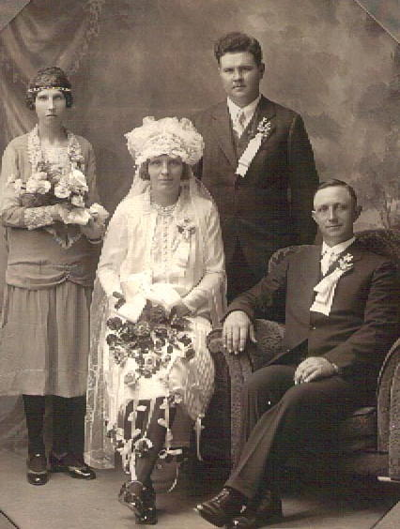
5.4. Wenzel Franzluebbers
Sept. 21, 1935*Mar. 16, 2012
5.5. Emil Franzluebbers
Oct. 21, 1937*Jan. 25, 1991
5.6. Anthony Franzluebbers
Nov. 24, 1939*
5.7. Bernadine Franzluebbers
Apr. 16, 1941*
5.8. Mary Ann Franzluebbers
Aug. 30, 1942*Dec. 24, 1942
5.9. Marie Franzluebbers
Nov. 25, 1943*July 16, 1967 Ben & Katie Franzluebbers, Oct. 1, 1928
Clara Ortmeier & Alois Kriekemeier

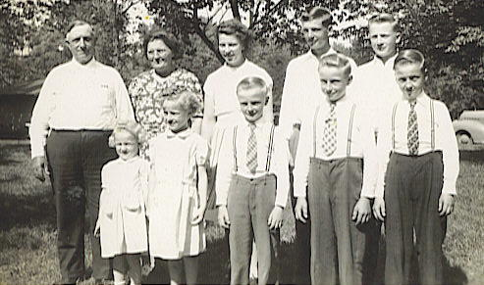
Ben & Katie Franzluebbers family,
ca. 1948

________________________________________________________________________
Anton Ortmeier, 1798; Ferdinand Ortmeier, 1834; 3.5 Herman Ortmeier, 1868;
4.4 Catherine Ortmeier Franzluebbers, 1901
5.1. Joseph Franzluebbers m. 01/05/1955 Rose Vogel
Oct. 3, 1930* West Point, NE Jan. 5, 1935*Olean, NE
6.1. Lois Franzluebbers
Sept. 24, 1955*
6.2. Kenneth Franzluebbers
Aug. 1, 1957*
6.3. Karen Franzluebbers
Aug. 10, 1960*
6.4. Lori Franzluebbers
Oct. 27, 1961*
6.5. Joseph Franzluebbers, Jr
Nov. 18, 1962*
________________________________________________________________________
Anton Ortmeier, 1798; Ferdinand Ortmeier, 1834; 3.5 Herman Ortmeier, 1868;
4.4 Catherine Ortmeier Franzluebbers, 1901; 5.1 Joseph Franzluebbers, 1930
6.1. Lois Franzluebbers m. 02/08/1975 Mark Johnson
Sept. 24, 1955* West Point, NE Jan. 4, 1956* West Point, NE
7.1. Matthew Johnson m. 06/15/2002 Wendy
Dec. 10, 1975* July 22, 1971*
8.1. Andrew Matthew Johnson
June 26, 2006*
8.2. Aaron & Nathan Johnson
Sept. 11, 2008*
7.2. Brian Johnson m. 09/04/1999 Nikki Bonsall
Apr. 25, 1979* West Point, NE May 4, 1980*
8.1. Isabelle Johnson
June 7, 2007*
7.3. Brent Johnson
Sept. 15, 1983*
6.2. Kenneth Franzluebbers
Aug. 1, 1957*
6.3. Karen Franzluebbers m. 01/04/1985 Gregory Ochsenbine
Aug. 10, 1960* West Point, NE Apr. 19, 1964* Warren, OH
7.1. Kyle David Ochsenbine
Apr. 17, 1988*
7.2. Andrea Ochsenbine
Oct. 22, 1990*
6.4. Lori Franzluebbers
Oct. 27, 1961* West Point, NE
6.5. Joseph Franzluebbers, Jr. m. 07/12/1986 Barbara Ulrich
Nov. 18, 1962* West Point, NE Dec. 28, 1963* West Point, NE
7.1. Jacob Franzluebbers
Nov. 6, 1987*
7.2. Chelsea Franzluebbers
Feb. 26, 1990*
7.3. Marissa Franzluebbers
June 5, 1994*
________________________________________________________________________
Anton Ortmeier, 1798; Ferdinand Ortmeier, 1834; 3.5 Herman Ortmeier, 1868;
4.4 Catherine Ortmeier Franzluebbers, 1901
5.2. Gertrude Franzluebbers m. 10/10/1956 Richard Ernesti
Jan. 6, 1932, West Point, NE*June 3, 2011 Nov. 11, 1932* West Point, NE
Buried at St. Aloysius Cemetery, Aloys, NE
6.1. Donald Ernesti
July 20, 1957*
6.2. Donna Ernesti
July 16, 1958*
6.3. Diane Ernesti
Sept. 21, 1960*
6.4. Bonnie Ernesti
Sept. 24, 1962*
6.5. Brian Ernesti
Aug. 30, 1967*
________________________________________________________________________
Anton Ortmeier, 1798; Ferdinand Ortmeier, 1834; 3.5 Herman Ortmeier, 1868;
4.4 Catherine Ortmeier Franzluebbers, 1901; 5.2 Gertrude Franzluebbers Ernesti, 1932
6.1. Donald Ernesti m. 02/16/1985 Wendy Marx
July 20, 1957* West Point, NE Dec. 6, 1960* Norfolk, NE
7.1. Chad Ernesti
Mar. 17, 1987*
7.2. Justine Ernesti
May 11, 1992*
6.2. Donna Ernesti m. 06/13/1992 Kurt Brester
July 16, 1958* West Point, NE Oct. 15, 1968* West Point, NE
7.1. Matthew Brester
July 21, 1993*
7.2. Mitchell Brester
June 30, 1997*
6.3. Diane Ernesti m. 10/13/1979 Marvin Ulrich
Sept. 21, 1960* West Point, NE Sept. 4, 1958* West Point, NE
7.1. Rachel Marie Ulrich m. 06/02/2007 Eric Schulz
Dec. 2, 1980* Jan. 22, (?)*
8.1 Logan Schulz
Oct.17, 2008*
7.2. Russel Ulrich
Jan. 11, 1984*
7.3. Jenna Ulrich
May 19, 1988*May 19, 1988
7.4. Amanda Ulrich
July 19, 1990*
6.4. Bonnie Kay Ernesti m.01/29/1962 Glen Kluthe
Sept. 24, 1962* West Point, NE div. 2003 Feb. 28, 1961* West Point, NE
7.1. Brandon Kluthe m. 06/19/2004 Katie Schneiderheinz
Jan. 5, 1982* Nov. 15, (?)

8.1. Karter Kluthe
Jan. 4, 2007*
7.2. Nicole Kluthe
Mar. 21, 1987*
7.3. Cody Kluthe
Feb. 11, 1991*
6.5. Brian Ernesti
Aug. 30, 1967*
________________________________________________________________________
Anton Ortmeier, 1798; Ferdinand Ortmeier, 1834; 3.5 Herman Ortmeier, 1868;
4.4 Catherine Ortmeier Franzluebbers, 1901
5.3. Charles Franzluebbers m. 04/14/1959 Irene Steffensmeier
Dec. 27, 1933* West Point, NE May 1, 1937* Cuming County NE
6.1. Thomas Franzluebbers
Mar. 20, 1960*
6.2. Alan J. Franzluebbers
Nov. 4, 1961*
6.3. Kevin J. Franzluebbers
Mar. 10, 1963*
6.4. Michael Franzluebbers
Nov. 19, 1964*
6.5. Ronald Franzluebbers
June 16, 1966*
6.6. Jared J. Franzluebbers
June 19, 1972*
________________________________________________________________________
Anton Ortmeier, 1798; Ferdinand Ortmeier, 1834; 3.5 Herman Ortmeier, 1868;
4.4 Catherine Ortmeier Franzluebbers, 1901; 5.3 Charles Franzluebbers, 1933
6.1. Thomas Franzluebbers m.06/22/1985 Judy Crane
Mar. 20, 1960* West Point, NE Dec. 15, 1963* Council Bluffs, IA
7.1. Sara Franzluebbers m. 06/2010 Austin Stanley
Jan. 6, 1986*
7.2. Mitchell Franzluebbers
Feb. 1, 1989*
6.2. Alan J. Franzluebbers m. 08/07/1992 Kathrin Grahammer
Nov. 4, 1961*
7.1. Berta Maria Franzluebbers
May 10, 1994*
7.2. Anton Eduard Franzluebbers
Sept. 23, 1996*
7.3. Sofia Clara Franzluebbers
Jan. 9, 2001*
6.3. Kevin J. Franzluebbers m. 07/31/2004 Lynn Marie Mormann
Mar. 10, 1963* 1972*
7.1. Aubrey Franzluebbers
2010*
6.4. Michael Franzluebbers m. 08/29/1992 Susan Eikmeier
Nov. 19, 1964* West Point, NE Oct. 11, 1964*
6.5. Ronald Franzluebbers m. 12/30/1989 Barbara Burger
June 16, 1966* West Point, NE Oct. 15, 1966* Omaha, NE
7.1. Ben Charles Franzluebbers
May 9, 1991*
7.2. Rachel Elaine Franzluebbers
July 15, 1994*
7.3. Leah Catherine Franzluebbers
Aug. 10, 1996*
6.6. Jared J. Franzluebbers m. 07/16/2005 Regina Dandinger
June 19, 1972* 1977*
________________________________________________________________________
Anton Ortmeier, 1798; Ferdinand Ortmeier, 1834; 3.5 Herman Ortmeier, 1868;
4.4 Catherine Ortmeier Franzluebbers, 1901
5.4. Wenzel Franzluebbers m. 01/31/1959 Cecilia Wuestewald
Sept. 21, 1931, West Point, NE*Mar. 16, 2012 June 8, 1937* Harrington, NE
Buried at Holy Cross Cemetery, Beemer, NE
6.1. Mark Franzluebbers
Apr. 1, 1964*
6.2. Patricia Franzluebbers
Nov. 8, 1967*
6.3. Steven Franzluebbers
Jan. 15, 1969*
6.4. James A. Franzluebbers
Feb. 10, 1972*
________________________________________________________________________
Anton Ortmeier, 1798; Ferdinand Ortmeier, 1834; 3.5 Herman Ortmeier, 1868;
4.4 Catherine Ortmeier Franzluebbers, 1901; 5.4 Wenzel Franzluebbers, 1931
6.1. Mark Franzluebbers m. 06/11/1988 Annette Maureen Hannon
Apr. 1, 1964* West Point, NE div. Nov. 14, 1964*
7.1. Ana Franzluebbers
July 30, 1991*
6.2. Patricia Franzluebbers m. 07/31/1993 Brent Lorensen
Nov. 8, 1967* West Point, NE Apr. 29, 1967* Lynch, NE
7.1. Alexandra Lorensen
Dec. 5, 1996*
7.2. Nicholas Lorensen
May 10, 1999*
7.3. Jack Lorensen
May 15, 2002*
6.3. Steven Franzluebbers m. 05/12/2001 Tiffany Whiting
Jan. 15, 1969* West Point, NE Mar. 31, 1970* CA
7.1. Zachary Franzluebbers
Oct. 4, 2004*

7.2. Matthew Franzluebbers
Mar. 29, 2007*
6.4. James A. Franzluebbers m. 06/10/1995 Karla Ortmeier
Feb. 10, 1972* West Point, NE Oct. 25, 1971* West Point, NE
7.1. Sophia Franzluebbers
July 18, 2008*
________________________________________________________________________
Anton Ortmeier, 1798; Ferdinand Ortmeier, 1834; 3.5 Herman Ortmeier, 1868;
4.4 Catherine Ortmeier Franzluebbers, 1901
5.5. Emil Franzluebbers m. 09/16/1961 Janet Peplinski
Oct. 21, 1937 West Point, NE*Jan. 25, 1991 July 6, 1941* Dodge, NE
Buried at St. Boniface Cemetery, Monterey, NE
6.1. Gary Franzluebbers
Aug. 11, 1962*
6.2. Daniel Franzluebbers
Nov. 25, 1963*
6.3. Patrick Franzluebbers
May 25, 1967*
6.4. Duane Franzluebbers
Mar. 24, 1976*
6.5. Brenda Franzluebbers
Dec. 31, 1977*
________________________________________________________________________
Anton Ortmeier, 1798; Ferdinand Ortmeier, 1834; 3.5 Herman Ortmeier, 1868;
4.4 Catherine Ortmeier Franzluebbers, 1901; 5.5 Emil Franzluebbers, 1937
6.1. Gary Franzluebbers m. 12/19/1986 Sherry Nass
Aug. 11, 1962* West Point, NE Sept. 4, 1969*
7.1. Brian Franzluebbers
May 20, 1988*
7.2. Amber Franzluebbers
June 2, 1990*
6.2. Daniel Franzluebbers m. 04/12/1990 Betty Van Winkle
Nov. 25, 1963* West Point, NE May 21, 1947* Syracuse, NY
6.3. Patrick Franzluebbers
May 25, 1967* West Point, NE
6.4. Duane Franzluebbers
Mar. 24, 1976* West Point, NE
6.5. Brenda Franzluebbers m. 07/08/2000 Eric Meis
Dec. 31, 1977* West Point, NE Apr. 14, 1976* Elgin, NE
7.1. Ashtyn Meis
Dec. 7, 2002*
7.2. Skylar Meis
Nov. 6, 2004*
7.3. Brooklyn Meis
Mar. 16, 2006*

________________________________________________________________________
Anton Ortmeier, 1798; Ferdinand Ortmeier, 1834; 3.5 Herman Ortmeier, 1868;
4.4 Catherine Ortmeier Franzluebbers, 1901
5.6. Anthony C. Franzluebbers m. 07/17/1971 Connie L. Carlson
Nov. 24, 1939* West Point, NE Jan. 31, 1947* Council Bluffs, IA
6.1. Andrew Franzluebbers
Nov. 11, 1972*
6.2. Becky Ann Franzluebbers
Feb. 2, 1975*
6.3. Cindy Lynette Franzluebbers
Oct. 16, 1978*
6.4. Ben Robert Franzluebbers
Sept. 22, 1988*
________________________________________________________________________
Anton Ortmeier, 1798; Ferdinand Ortmeier, 1834; 3.5 Herman Ortmeier, 1868;
4.4 Catherine Ortmeier Franzluebbers, 1901; 5.6 Anthony Franzluebbers, 1939
6.1. Andrew Franzluebbers m. 11/02/2002 Joani Paulsen
Nov. 11, 1972* West Point, NE Jan. 11, 1978*
7.1 Nathan Franzluebbers
May 23, 2008*
7.2. Madelyn Franzluebbers
Oct. 2, 2009*
6.2. Becky Ann Franzluebbers m. 05/24/2003 Lindomar (Tex) Teixeira
Feb. 2, 1975* Dodge, NE July 7, 1971*
7.1. Lance Carter Teixeira
Mar. 9, 2008*
6.3. Cindy Lynette Franzluebbers
Oct. 16, 1978* West Point, NE
6.4. Ben Robert Franzluebbers
Sept. 22, 1988*
________________________________________________________________________
Anton Ortmeier, 1798; Ferdinand Ortmeier, 1834; 3.5 Herman Ortmeier, 1868;
4.4 Catherine Ortmeier Franzluebbers, 1901
5.7. Bernadine Franzluebbers m. 04/24/1962 Melvin Kampschnieder
Apr. 16, 1941* West Point, NE Dec. 31, 1939* Olean, NE
Adopted children:
6.1. Jeffrey Allen Kampschnieder
Aug. 11, 1967*
6.2. Keith Allen Kampschnieder
Sept. 3, 1970*
________________________________________________________________________
Anton Ortmeier, 1798; Ferdinand Ortmeier, 1834; 3.5 Herman Ortmeier, 1868;
4.4 Catherine Ortmeier Franzluebbers, 1901; 5.7 Bernadine Franzluebbers Kampschnieder, 1941
6.1. Jeffrey Allen Kampschnieder m. 05/29/1993 Yvette Rassmann
Aug. 11, 1967* Omaha, NE Feb. 18, 1971* West Point, NE
7.1. Kaden Kampschnieder
May 12, 2006*
7.2. Maddox Kampschnieder
Mar. 3, 2009*
7.3. Addison Kampschnieder
Mar. 3, 2009*
6.2. Keith Allen Kampschnieder
Sept. 3, 1970* Omaha, NE
7.1. Taylor Jo Kampschnieder
Jan. 8, 2001*
7.2. Tanner James Kampschnieder
Feb. 27, 2003*
________________________________________________________________________
Anton Ortmeier, 1798; Ferdinand Ortmeier, 1834; 3.5 Herman Ortmeier, 1868;
4.4 Catherine Ortmeier Franzluebbers, 1901
5.8. Mary Ann Franzluebbers
Aug. 30, 1942*Dec. 24, 1942
Buried at St. Boniface Cemetery, Monterey, NE
________________________________________________________________________
Anton Ortmeier, 1798; Ferdinand Ortmeier, 1834; 3.5 Herman Ortmeier, 1868;
4.4 Catherine Ortmeier Franzluebbers, 1901
5.9. Marie Franzluebbers m. 04/08/1967 Gene Moser
Nov 25, 1943*July 16, 1967 Dec. 21, 1942*
Buried at St. Boniface Cemetery, Monterey, NE

Anna Ortmeier and Paul Herrmann
______________________________________________________________________________________
______________________________________________________________________________________
Anton Ortmeier, 1798; Ferdinand Ortmeier, 1834; 3.5 Herman Ortmeier, 1868
4.5. Anna Theresa Ortmeier m. 04/11/1932 Paul Adle Gella Herrmann
Oct. 15, 1903* West Point, NE Oct. 2, 1892* West Point, NE
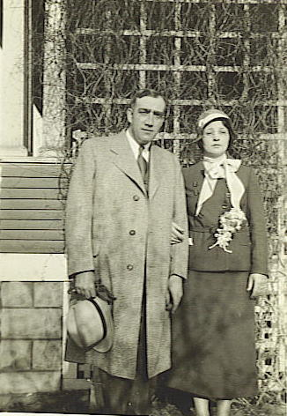
Mar. 25, 1987 Apr. 20, 1978
Both are buried at Mt. Hope Cemetery, West Point, NE
Occupations: Ann: Homemaker/clerk/caterer/nanny
Paul: Took orders & delivered groceries for Goldsmith Store
Interests: Ann: Loved to bake and sew; was a whiz at crocheting and liked to decorate Paul: Liked to garden and read; liked to go to town on Saturday night, walk the streets, visit with everyone he knew; liked movies & baseball games.

Paul & Anna Herrmann
Apr. 11, 1932
________________________________________________________________________
Anton Ortmeier, 1798; Ferdinand Ortmeier, 1834; 3.5 Herman Ortmeier, 1868;
4.5 Anna Ortmeier Herrmann, 1903
5.1. Paula Ann Herrmann
Oct. 10, 1938, West Point, NE*Mar. 16, 2010
Buried at Mt. Hope Cemetery, West Point, NE

Clara Ortmeier and Frank Monteforte
______________________________________________________________________________________
______________________________________________________________________________________
Anton Ortmeier, 1798; Ferdinand Ortmeier, 1834; 3.5 Herman Ortmeier, 1868
4.6. Clara Mary Ortmeier m. 09/18/1934 Frank Monteforte
Feb. 8, 1906* West Point, NE Sept. 6, 1893* Cala Sciobetta, Italy
Aug. 17, 1989 Apr. 9, 1961
Both are buried at St. Leo’s Cemetery, Snyder, NE
(Clara) m. 11/17/1967 Howard Melvin Wanned
Dec. 23, 1909*Apr. 24, 1969
Buried at St. Bonaventure Cemetery, Columbus, NE
5.1. Hermina Monteforte
July 1, 1935*
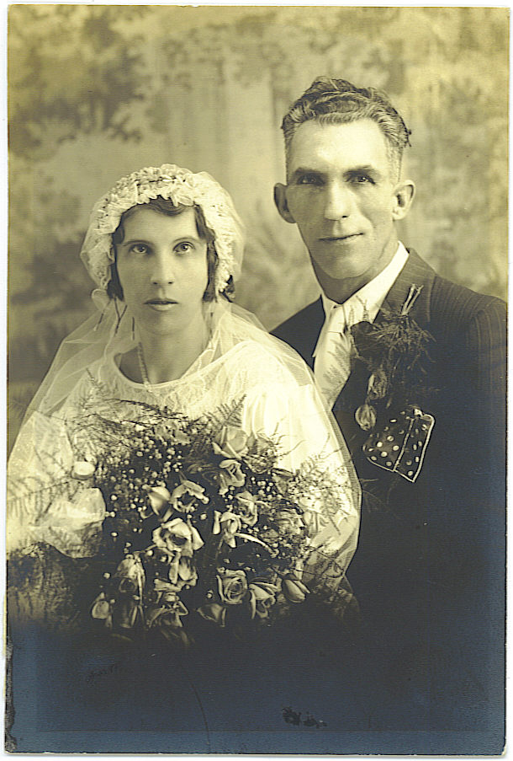
5.2. Herman Carl Monteforte
Sept. 18, 1936*
5.3. Margaret Clara Monteforte Clara & Frank Monteforte,
June 7, 1938* Sept. 8, 1934
5.4. Marion Louise Monteforte
June 12, 1940*
5.5. Martha Agnes Monteforte
Jan. 23, 1943*
5.6. Frank Monteforte, Jr.
Mar. 18, 1944*
5.7. Rita Theresa Monteforte
June 17, 1945*
5.8. Joseph Casper Monteforte
Dec. 27, 1946*
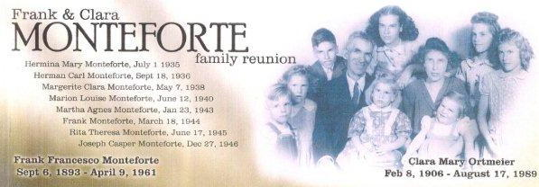

______________________________________________________________________
Anton Ortmeier, 1798; Ferdinand Ortmeier, 1834; 3.5 Herman Ortmeier, 1868;
4.6 Clara Ortmeier Monteforte Wanned, 1906
5.1. Hermina Monteforte m. 04/23/1954 Roy E. Jones
July 1, 1935* Olean, NE June 28, 1932 Omaha, NE*Sept. 29, 2007
Buried at Cedar Dale Cemetery, Papillion, NE
6.1. Patricia Lorraine Jones
Nov. 6, 1955*
6.2. Richard Paul Jones
May 17, 1957*
6.3. Joanne Marie Jones
July 28, 1958*
6.4. Michael John Jones
Aug. 19, 1959*
6.5. Thomas Bernard Jones
Sept. 24, 1960*
6.6. Donald Eugene Jones
Feb. 7, 1962*
6.7. Dianne Lynn Jones
Sept. 24, 1963*
________________________________________________________________________
Anton Ortmeier, 1798; Ferdinand Ortmeier, 1834; 3.5 Herman Ortmeier, 1868;
4.6 Clara Ortmeier Monteforte Wanned, 1906; 5.1 Hermina Monteforte Jones, 1935
6.1. Patricia Lorraine Jones m. 11/07/1975 Charles A. Gaddis III
Nov. 6, 1955* div. 1981 Aug. 20, 1954*
7.1. Teresa Joelle Gaddis m. 8/12/1994 Todd Parson
Mar. 7, 1976* div. 7/22/1997 Jan. 28, 1975*
(Teresa) m. 6/03/2006 Josh Matthies
Nov. 15, 1974*
8.1. Gage Michael Parson
Sept. 13, 1993*
8.2. Clayton Joseph Parson
Oct. 12, 1995*
8.3. Hunter Lee Taylor
Aug. 12, 1997*
8.4. Jadelyn Marie Taylor
June 21, 2000*
8.5. Mason D. Matthies
July 23, 2008*
7.2. Charles Roy Gaddis
Feb. 7, 1979*
8.1. Jacob Gaddis
Aug. 29, 2006*
7.3. Christina Marie Gaddis m. 6/17/2000 James Allen
Feb. 7, 1979* Apr. 14, 1977*
Stepson: 8.1. Nicholas Allen
Jan. 15, 1994*
8.2. Kealii Lynn Allen
Dec. 15, 2008*
7.4 Tye Shallenberger
June 20, 1994*

6.2. Richard Paul Jones m. 10/08/1982 Laurie J. Wischmann
May 17, 1957* Oct. 17, 1958*
7.1. Gary Paul Jones
Mar. 10, 1985*
7.2. Daniel Edward Jones
Apr. 22, 1988*
6.3. Joanne Marie Jones m. 09/14/1984/d. Michael J. Gassert
July 28, 1958* Omaha, NE May 20, 1956*
7.1. Michaela Marie Gassert m. 07/18/2009 Lee Kortus
Mar. 10, 1986* June 18, 1985*
7.2. Cortney Lynn Gassert m. 11/27/2010 Josh Grimus
Sept. 2, 1988* Sept. 6, 1983*
(Joanne) m.07/03/2010 Michael Albrecht
6.4. Michael John Jones m. 09/24/1983 – div. Debbie Reimers
Aug. 19, 1959* May 8, 1961*
6.5. Thomas Bernard Jones m. 05/19/1984 Sandy Palu
Sept. 24, 1960* Aug. 19, 1961*
7.1. Rosemarie Lynn Jones m. 05/24/2008 David Neal
Mar. 9, 1984*
7.2. Angela Suzanne Jones
Feb. 25, 1985*
8.1. Lacey Lynn Farmer
July 17, 2007*
7.3. Tiffany Elizabeth Jones
Sept. 15, 1987*
7.4. Holly Ann Jones
Feb. 7, 1990*
7.5. Justin Thomas Jones
May 27, 1993*
6.6. Donald Eugene Jones m. 09/28/1991 Patricia Ziegler
Feb. 7, 1961* Sept. 5, 1965*
7.1. Madison Paige Jones
July 17, 1998*
7.2. Katelyn Elizabeth Jones
Nov. 16, 2000*
6.7. Dianne Lynn Jones m. 07/21/1990 Gary Carlson
Sept. 24, 1963* Omaha, NE Mar. 28, 1962* St. Paul, MN
7.1. Nicole Lynn Carlson
Dec. 10, 1995*
________________________________________________________________________
Anton Ortmeier, 1798; Ferdinand Ortmeier, 1834; 3.5 Herman Ortmeier, 1868;
4.6 Clara Ortmeier Monteforte Wanned, 1906
5.2. Herman Carl Monteforte m. 10/26/1968 Mildred A. Stroh
Sept. 18, 1936* Sept. 27, 1944*
_______________________________________________________________________
Anton Ortmeier, 1798; Ferdinand Ortmeier, 1834; 3.5 Herman Ortmeier, 1868;
4.6 Clara Ortmeier Monteforte Wanned, 1906
5.3. Margarite Clara Monteforte m. 12/19/1959 David R. Ellis
May 7, 1938* Snyder, NE Aug. 21, 1939* Anniston, AL

6.1. Debora Louise Ellis
Oct. 19, 1960*
6.2. Donna Marie Ellis
Nov. 18, 1962*
6.3. Nancy Jean Ellis
Oct. 26, 1967*
________________________________________________________________________
Anton Ortmeier, 1798; Ferdinand Ortmeier, 1834; 3.5 Herman Ortmeier, 1868;
4.6 Clara Ortmeier Monteforte Wanned, 1906; 5.3 Margarite Monteforte Ellis, 1938
6.1. Debora Louise Ellis m. 07/22/1978 – div. Frank Granich
Oct. 19, 1960* Minneapolis, MN July 30, 1956*
(Debra) m. 07/18/1984 Jim Mencum
Oct. 31, 1956*
(Debra) m. 11/10/2001 Tuan Tran
6.2. Donna Marie Ellis m. 10/08/1990 Michael Perry
Nov. 18, 1962, Biloxi, MS*Apr. 12, 2011 Jan. 13, 1966* Staten Island, NY
Buried at Hawaii State Veterans Cemetery, Kaneohe, HI
7.1. Calla Latrice Perry
Mar. 24, 1987*
8.1. Theryn B. Perry
Mar. 8, 2009*
7.2. Carissa Michelle Perry
Nov. 26, 1990*
8.1 Makaylah A. Perry
May 16, 2006*
7.3. Michael A. Perry
Mar. 2, 2003*
6.3. Nancy Jean Ellis m. 04/17/1987 – div. 03/1999 Justin L. Martin
Oct. 26, 1967* Phoenix, AZ Apr. 5, 1965*
7.1. Justine A. Martin
Aug. 28, 1991*
(Nancy) m. 01/01/2001 Sean Law
7.2. David J. Law
Aug. 15, 2001*
________________________________________________________________________
Anton Ortmeier, 1798; Ferdinand Ortmeier, 1834; 3.5 Herman Ortmeier, 1868;
4.6 Clara Ortmeier Monteforte Wanned, 1906
5.4. Marion Louise Monteforte m. 02/29/1960 – div. Richard A. Jasper
June 12, 1940* Snyder, NE Sept. 11, 1935*
6.1. Cynthia Marie Jasper
Mar. 6, 1961*
6.2. Sharon Lynn Jasper
Jan. 16, 1964*
6.3. Patricia Eileen Jasper
July 27, 1965*Sept. 28, 1965

________________________________________________________________________
Anton Ortmeier, 1798; Ferdinand Ortmeier, 1834; 3.5 Herman Ortmeier, 1868;
4.6 Clara Ortmeier Monteforte Wanned, 1906; 5.4 Marion Monteforte Jasper, 1940
6.1. Cynthia Marie Jasper m. 12/02/1983 Connie E. Reese
Mar. 6, 1961* Beaufort, SC Dec. 1, 1948* Columbus, NE
7.1. Jennifer Lynn Reese (step)
Jan. 22, 1973*July 1, 2004
7.2. Jillian Mae Reese m. James Lee
Feb. 13, 1989* Columbus, NE Jan. 9, 1986* MI
7.3. Benjamin Reese
Apr. 8, 1992*
6.2. Sharon Lynn Jasper m. 10/18/1986 – div. Robert L. Williams
Jan. 16, 1964* Orange County, CA Apr. 22, 1951*
7.1. Ashley Nicole Williams
Mar. 15, 1987*
(Sharon) m. 01/15/1993 Mark Healy
Aug. 17, 1962* Kansas City, MO
7.2. Amanda Nicole Healy
Aug. 22, 1994*
7.3. Angela Nicole Healy
May 23, 1999*
6.3. Patricia Eileen Jasper
July 27, 1965*Sept. 28, 1965
(Marion) m. 08/16/1980 Frank J. Nadrchal
June 1, 1928*Aug. 27, 1997
Buried at Roselawn Cemetery, Columbus, NE
Step-Children:
6.4. Randy Lee Nadrchal m.10/15/1983 div. Linda Michaelsen
June 21, 1956* Columbus, NE Aug. 3, 1958* Columbus, NE
7.1. Karlee Sue Nadrchal Eaton
Oct. 6, 1986*
8.1. Kiera Eaton
Mar. 12, 2008
8.2. Chloe Eaton
Mar. 10, 2009*
6.5. Cindy Elaine Nadrchal m. 05/30/1981 Richard Patrick Vandenberg
July 7, 1958* Columbus, NE July 4, 1952* Omaha, NE
7.1. Anthony Frank Vandenberg
Mar. 30, 1984*
7.2. Michael Joseph Vandenberg
Jan. 22, 1987*
________________________________________________________________________
Anton Ortmeier, 1798; Ferdinand Ortmeier, 1834; 3.5 Herman Ortmeier, 1868;
4.6 Clara Ortmeier Monteforte Wanned, 1906
5.5. Martha Agnes Monteforte m. 06/25/1960 Joseph Siedlik
Jan. 23, 1943* Snyder, NE May 13, 1934* Omaha, NE
6.1. Michael Joseph Siedlik
Apr. 28, 1961*
6.2. Steven Paul Siedlik
Aug. 26, 1963*
6.3. Jeanne Marie Siedlik
Dec. 20, 1967*
6.4. Susan Ann Siedlik
Apr. 2, 1971*
6.5. Jane Mary Siedlik
Jan. 5, 1977*
________________________________________________________________________
Anton Ortmeier, 1798; Ferdinand Ortmeier, 1834; 3.5 Herman Ortmeier, 1868;
4.6 Clara Ortmeier Monteforte Wanned, 1906; 5.5 Martha Monteforte Siedlik, 1943
6.1. Michael Joseph Siedlik m. 05/09/1981 – div. Tamala Kemp
Apr. 28, 1961* Omaha, NE
(Michael) m. 06/02/1990 Barbara Bejvancesky
Mar. 9, 1953* Seward, NE
6.2. Steven Paul Siedlik m. 12/20/1986 Debora Williams
Aug. 26, 1963*
7.1. Amanda Lee Siedlik
July 29, 1987*Apr. 28, 2001
Buried at Mount Moriah Cemetery South, Kansas City, MO
(Steven) m. 05/23/1993 Christina M. Larsen
7.2. Amy Siedlik
Feb. 22, 1995*
6.3. Jeanne Marie Siedlik m. 04/27/1991 Marvin Earnest Sidel, Jr.
Dec. 20, 1967* Columbus, NE Jan. 10, 1962* Aurora, NE
7.1. Shelby Joseph Sidel
Aug. 16, 1990*
7.2. Chelsea Clara Sidel
Feb. 6, 1995*
6.4. Susan Ann Siedlik m. 10/12/2000 Mark A. Spohn
Apr. 2, 1971* Columbus, NE Mar. 2, 1971*
7.1. Sarah Mackenzie Spohn
Apr. 1, 2002*
7.2. Alexander James Spohn
Oct. 8, 2007*
6.5. Jane Mary Siedlik m. Vinnie Romero
Jan. 5, 1977* Columbus, NE Aug. 29, 1972* Kansas City, MO
7.1. Kayla Jayne Romero
Nov. 29, 2003*
________________________________________________________________________
Anton Ortmeier, 1798; Ferdinand Ortmeier, 1834; 3.5 Herman Ortmeier, 1868;
4.6 Clara Ortmeier Monteforte Wanned, 1906
5.6. Frank Monteforte, Jr. m. 12/16/1967 Mary June Phillips
Mar. 18, 1944* June 22, 1942*Oct. 5, 2008
Cremated
6.1. Donna M. Monteforte
May 24, 1961*Apr. 21, 2008
6.2. Frank Michael Monteforte, III
Nov. 19, 1968*
6.3. Mellissa Monteforte
Feb. 16, 1980*
________________________________________________________________________
Anton Ortmeier, 1798; Ferdinand Ortmeier, 1834; 3.5 Herman Ortmeier, 1868;
4.6 Clara Ortmeier Monteforte Wanned, 1906; 5.6 Frank Monteforte, Jr., 1944
6.1. Donna M. Monteforte m. – div. Doug Chudomelka
May 24, 1961*Apr. 21, 2008
Buried at Eternal Hills Memorial Park, San Diego, CA
(Donna) m. 04/25/1987 – div. John Appenzeller
6.2. Frank Michael Monteforte, III m. 07/29/1989 Vera Gallegos
Nov. 19, 1968* Norfolk, England Oct. 28, 1969* Oceanside, CA
7.1. Autumn Maria Monteforte
Sept. 13, 1992*
7.2. Brandie Alexis Monteforte
June 24, 1995*
6.3. Mellissa Monteforte m. 09/06/1998 David Jimenez
Feb. 16, 1980*
7.1. Elijah Anthony Jimenez
May 7, 1999*
7.2. Isaac Gerard, Jimenez
Apr. 5, 2001*
7.3. Isabella Eliana Lourdes Jimenez
Mar. 27, 2004*
________________________________________________________________________
Anton Ortmeier, 1798; Ferdinand Ortmeier, 1834; 3.5 Herman Ortmeier, 1868;
4.6 Clara Ortmeier Monteforte Wanned, 1906
5.7. Rita Theresa Monteforte m. 06/26/1964 – div. Lonnie Hoffman
June 17, 1945* Sept. 6, 1942*
6.1. Wayne Neal Hoffman
Feb. 14, 1967*
6.2. Ronald Gene Hoffman
Apr. 16, 1969*
6.3. Gail Hoffman
June 14, 1971*
(Rita) m. Alfred Ferguson
6.4. Theresa Mary Ferguson
Aug. 28, 1979*
________________________________________________________________________
Anton Ortmeier, 1798; Ferdinand Ortmeier, 1834; 3.1 Herman Ortmeier, 1868;
4.6 Clara Ortmeier Monteforte Wanned, 1906; 5.7 Rita Monteforte Hoffman, 1945

6.1. Wayne Neal Hoffman m. Barbara Krom
Feb. 14, 1967* West Point, NE
7.1. Meagan Hoffman
May 14, 1989*
7.2. Wayne Hoffman, Jr.
Dec. 24, 1991*
7.3. Lonny Hoffman
Sept. 16, 1992*
7.4. Amber Hoffman
Sept. 27, 1996*
6.2. Ronald Gene Hoffman-Kloster m. 10/20/1990 Lynn Marie Buse
Apr. 16, 1969*
7.1.Cassandra
6.3. Gail Hoffman
June 14, 1971*
6.4. Theresa Mary Ferguson
Aug. 28, 1979*
________________________________________________________________________
Anton Ortmeier, 1798; Ferdinand Ortmeier, 1834; 3.5 Herman Ortmeier, 1868;
4.6 Clara Ortmeier Monteforte Wanned, 1906
5.8. Joseph Casper Monteforte m. 08/29/1969 Constance Girmus
Dec. 27, 1946* Snyder, NE Jan. 18, 1949* Geneva, NE
6.1. Joseph C. Monteforte, Jr.
Apr. 6, 1970*
6.2. Jean Ann Monteforte
Jan. 20, 1973*
________________________________________________________________________
Anton Ortmeier, 1798; Ferdinand Ortmeier, 1834; 3.5 Herman Ortmeier, 1868;
4.6 Clara Ortmeier Monteforte Wanned, 1906; 5.8. Joseph Casper Monteforte
6.1. Joseph C. Monteforte, Jr. m. 07/13/1991 Kristen M. Anderson
Apr. 6, 1970* Geneva, NE Mar. 12, 1971* Kansas City, MO
7.1. Morgan Monteforte
June 15, 1994*
7.2. Colin Monteforte
Feb. 9, 1996*
7.3. Lauryn Monteforte
February 4, 2001*
6.2. Jean Ann Monteforte m. Jim Engle
Jan. 20, 1973* Geneva, NE June 8, 1970* Friend, NE
7.1. Jared Allen Engle
Oct. 8, 2001*
7.2. Jorden Anton Engle
Jan. 27, 2005*

Theresa Ortmeier and Emil Huhman
________________________________________________________________________
________________________________________________________________________
Anton Ortmeier, 1798; Ferdinand Ortmeier, 1834; 3.1 Herman Ortmeier, 1868
4.7. Theresa Antonia Ortmeier m. 01/20/1932 Emil Joseph Huhman
July 5, 1908* Aloys, NE June 27, 1907* St. Elizabeth, MO
Dec. 15, 2002 Apr. 7, 1983
Both are buried at St. Bonaventure Cemetery, Columbus, NE
Occupations: Theresa: Farmwife/LPN/cook; Emil: Farmer/cabdriver/handyman
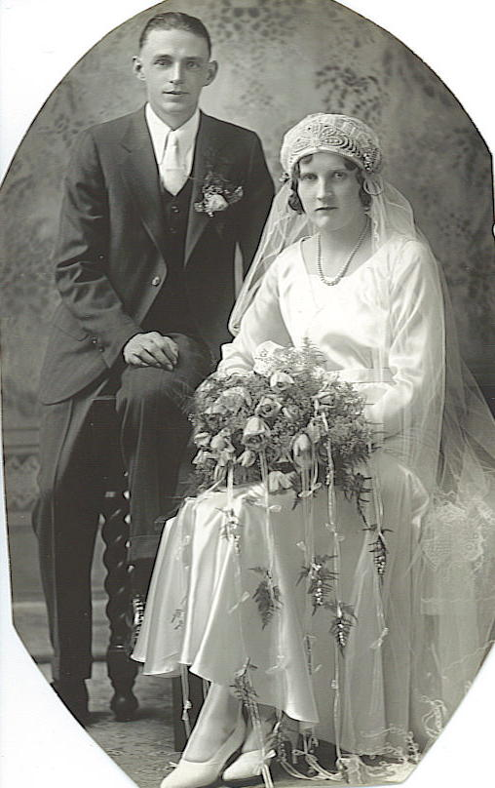
5.1. Leander Wenzel Huhman
May 19, 1933*May 22, 1933
5.2. Francis George Huhman
May 13, 1934*Aug. 30, 1937
5.3. Emil Louis Huhman
Mar. 4, 1936* Emil & Theresa Huhman,
5.4. Veronica Caroline Huhman Jan. 20, 1932
July 19, 1937*
5.5. Agnes Katherine Huhman
Aug. 29, 1939*
5.6. Catherine Mae Huhman
Mar. 24, 1941*
5.7. James Clement Huhman
Aug. 2, 1942*

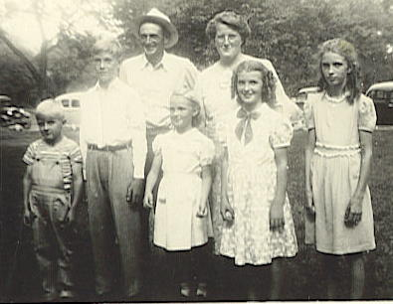
Emil & Theresa Huhman family,
ca. 1948

________________________________________________________________________
Anton Ortmeier, 1798; Ferdinand Ortmeier, 1834; 3.5 Herman Ortmeier, 1868;
4.7 Theresa Ortmeier Huhman, 1908
5.1. Leander Wenzel Huhman
May 19, 1933*May 22, 1933
5.2. Francis George Huhman
May 13, 1934*Aug. 30, 1937
Both are buried at Holy Cross Cemetery, Beemer, NE
________________________________________________________________________
Anton Ortmeier, 1798; Ferdinand Ortmeier, 1834; 3.5 Herman Ortmeier, 1868;
4.7 Theresa Ortmeier Huhman, 1908
5.3. Emil Louis Huhman m. 06/01/1963 Barbara Jean Treadway
Mar. 4, 1936* May 31, 1942*July 30, 1996
Buried at St. Bonaventure Cemetery, Columbus, NE
6.1. Ann Marie Huhman
July 12, 1964* Jan. 21, 2005
6.2. Carol Sue Huhman
Aug. 3, 1968*
6.3. David Joseph Huhman
Aug. 4, 1971*
6.4. Patricia Kay Huhman
Mar. 17, 1973*
6.5. James Eugene Huhman
July 15, 1977*
6.6. Jennifer Lynn Huhman
Feb. 7, 1979*
6.7. Kristina Lee Huhman
Apr. 14, 1981*
6.8. John Louis Huhman
Mar. 24, 1984*
________________________________________________________________________
Anton Ortmeier, 1798; Ferdinand Ortmeier, 1834; 3.5 Herman Ortmeier, 1868;
4.7 Theresa Ortmeier Huhman, 1908; 5.3 Emil Louis Huhman, 1936
6.1. Ann Marie Huhman m. 03/30/1984 div. Tom Davenport
July 12, 1964* Nov. 21, 2005
Buried at St. Bonaventure Cemetery, Columbus, NE
(Ann) m. 09/15/1992 Valente Corona-Lopez
div. 09/14/1999 May 21, 1970* Campeche, Mexico
7.1. Silvia Rose Corona
June 13, 1997* Norfolk, NE
7.2. Antonio Rodrigo Corona
Aug. 17, 1998* Norfolk, NE
After Ann’s death, the children went to her sister, Patti.
6.2. Carol Sue Huhman
Aug. 3, 1968* Columbus, NE
6.3. David Joseph Huhman
Aug. 4, 1971* Columbus, NE
6.4. Patricia Kay Huhman
Mar. 17, 1973* Columbus, NE
7.1. Suzanne Marie Huhman
Dec. 28, 1993* Columbus, NE
6.5. James Eugene Huhman
July 15, 1977* Columbus, NE
6.6. Jennifer Lynn Huhman m. 04/11/2000 Jeffrey Patrick Robak
Feb. 7, 1979* Columbus, NE Mar. 24, 1964* Columbus, NE
7.1. Ambriella Shree Robak
Nov. 13, 2000*
7.2. Amber Nicole Robak
Feb. 27, 2004*
7.3. Natalie Jean Robak
Jan. 31, 2007*
6.7. Kristina Lee Huhman m. 01/22/1998 –div. Dave Allen Thomas
Apr. 14, 1981* Columbus, NE
(Kristina) m. 01/22/2004 Roger Louis Williams
7.1. Sabrina Nicole Williams
Apr. 16, 2004*
7.2. Dakota Lee Williams
May 26, 2006*
7.3. Samantha Marie Williams
Dec. 20, 2008*
7.4. Maria Jean Williams
June 7, 2010*
6.8. John Louis Huhman
Mar. 24, 1984* Columbus, NE
________________________________________________________________________
Anton Ortmeier, 1798; Ferdinand Ortmeier, 1834; 3.5 Herman Ortmeier, 1868;
4.7 Theresa Ortmeier Huhman, 1908
5.4. Veronica Caroline Huhman m. 09/12/1957 Norman Hans Kiuntke
July 19, 1937* Beemer, NE June 3, 1932, Columbus, NE*June 1, 2002
Buried at Fairview Cemetery, Creston, NE
6.1. Timothy Joel Kiuntke
June 25, 1958*
6.2. Theresa Rose Kiuntke
Sept. 21, 1959*
6.3. Tobias Joseph Kiuntke
Apr. 22, 1971*
________________________________________________________________________
Anton Ortmeier, 1798; Ferdinand Ortmeier, 1834; 3.5 Herman Ortmeier, 1868;
4.7 Theresa Ortmeier Huhman, 1908; 5.4 Veronica Huhman Kiuntke, 1937
6.1. Timothy Joel Kiuntke m. 09/29/1984 Deborah Starascik
June 25, 1958* Columbus, NE div. 09/1988 June 2, 1964*
significant other Beverly Baer
(Matthew & Michael)
6.2. Theresa Rose Kiuntke m. 12/26/1987 Leonard Gabriel
Sept. 21, 1959* Columbus, NE Sept. 31, 1950* Fullerton, NE
6.3. Tobias Joseph Kiuntke m. 07/02/1994 Jean Katherine Gaspers
Apr. 22, 1971* Columbus, NE Jan. 15, 1970* Genoa, NE
7.1. Joe William Gaspers Kiuntke
July 14, 1991*
7.2. Veronica Katherine Kiuntke
Apr. 1, 1995*
7.3. John Henry Kiuntke
May 3, 1997*
7.4. Andrew Norman Kiuntke
Dec. 7, 2002*
7.5. Adam Jacob Kiuntke
June 27, 2006*
________________________________________________________________________
Anton Ortmeier, 1798; Ferdinand Ortmeier, 1834; 3.5 Herman Ortmeier, 1868;
4.7 Theresa Ortmeier Huhman, 1908
5.5. Agnes Katherine Huhman m. 07/02/1959 Cornelius Farrell Kelly
Aug. 29, 1939* Beemer, NE Jan.16, 1936* Detroit, MI
6.1. Mary Teresa Kelly
Aug. 7, 1961*
6.2. John Farrell Kelly
June 13, 1963*
6.3. Thomas Brennen Kelly
Nov. 3, 1964*
6.4. Anastasia Kelly
Dec. 27, 1965*
6.5. Catherine Kelly
July 27, 1967*
6.6. Patrick Kavanaugh Kelly
Dec. 6, 1968*
6.7. Elizabeth Kelly
May 9, 1970*
6.8. Michael Cornelius Kelly
Dec. 4, 1973*
6.9. Meghan Kelly
May 22, 1975*
6.10. Carlos Jose Kelly
Sept. 10, 1977*
________________________________________________________________________
Anton Ortmeier, 1798; Ferdinand Ortmeier, 1834; 3.5 Herman Ortmeier, 1868;
4.7 Theresa Ortmeier Huhman, 1908; 5.5 Agnes Huhman Kelly, 1939
6.1. Mary Teresa Kelly m. 07/11/1992 John Benson
Aug. 7, 1961* Wayne, NE div. 07/07/04 Sept. 13, 1945* Cheyenne, WY
7.1. Emily Marie (Emma) Benson
Oct. 7, 1995*
7.2. Brenna Rose (Rosie) Benson
May 3, 1999*
6.2. John Farrell Kelly
June 13, 1963* Osceola, NE
6.3. Thomas Brennen Kelly m. 08/03/1996 Laura Gail Woodson
Nov. 3, 1964* Osceola, NE Jan. 12, 1968* Laramie, WY
7.1. Ian Lee Kelly
July 6, 1999*
7.2. Tucker Blake Kelly
Mar. 30, 2002*
6.4. Anastasia Kelly m. 12/30/1992 - div. Richard Leger
Dec. 27, 1965* Osceola, NE Sept. 13, 1945*
(Anya) m. 11/18/2000 Fabiano Esposito
Mar. 6, 1955*Marigliano, Naples, Italy
6.5. Catherine Kelly never married Andre Smith, Muslim aka
July 27, 1967* Columbus, NE Sayeed Jamal Minneapolis, MN
7.1. Tigerlily Kelly
Jan. 26, 1996*
6.6. Patrick Kavanaugh Kelly m. 08/18/1996 Kathleen Akemi Kondo
Dec. 6, 1968* Laramie, WY Feb. 16, 1967* Honolulu, HI
7.1. Chloe Kiemi Kelly
Oct. 21, 2001*
7.2. Kian Jett Kelly
Jan. 5, 2005*
6.7. Elizabeth Kelly never married Ricky Murphy
May 9, 1970* Fremont, NE
7.1. Abra Kelly Murphy
Sept. 29, 1993*
7.2. Omani Kelly Murphy
June 10, 1995*
7.3. Izell Kelly Murphy
May 30, 1997*
7.4. Ezra Kelly Murphy
May 7, 2000*
6.8. Michael Cornelius Kelly m.01/01/2003 Katherine Munroe Swift
Dec. 4, 1973* Jackson, WY Feb. 12, 1977*
7.1. Miriam Anastasia Kelly
Dec. 7, 2008*
7.2. Sarah Cornelia Kelly
July 24, 2010*
6.9. Meghan Kelly never married Todd Charles Sayland
May 22, 1975* Jackson, WY 12/17/?, Horsham, PA
7.1. Elijah Sayland Kelly
Apr. 29, 1996*
6.10. Carlos Jose Kelly
Sept. 10, 1977* Jackson, WY
________________________________________________________________________
Anton Ortmeier, 1798; Ferdinand Ortmeier, 1834; 3.5 Herman Ortmeier, 1868;
4.7 Theresa Ortmeier Huhman, 1908
5.6. Catherine Mae Huhman m. 10/07/1959 Florian Charles Placzek
Mar. 24, 1941* Beemer, NE* Aug. 18, 1940, Tarnov, NE*May 1, 2011
Cremated
6.1. Denise Marie Placzek
July 12, 1960*
6.2. Sandra Balbina Placzek
Oct. 21, 1961*
6.3. Florian Anthony Placzek
Oct. 3, 1962*
6.4. Marni Louise Placzek
Aug. 19, 1971*
________________________________________________________________________
Anton Ortmeier, 1798; Ferdinand Ortmeier, 1834; 3.5 Herman Ortmeier, 1868;
4.7 Theresa Ortmeier Huhman, 1908; 5.6 Catherine Huhman Placzek, 1941
6.1. Denise Marie Placzek m. 08/06/1982 Michael Robert Hokanson
July 12, 1960* Omaha, NE Mar. 7, 1959* Omaha, NE
7.1. Robert Ryan Hokanson
Feb. 10, 1988*
7.2. Emily Marie Hokanson
June 20, 1994*
6.2. Sandra Balbina Placzek
Oct. 21, 1961*
6.3. Florian Anthony Placzek (Tony)m. 05/29/1987 Brenda Street
Oct. 3, 1962* Omaha, NE div.
7.1. Kyle Jared (Placzek) Sullivan
Apr. 29, 1988*Oct. 20, 2009
Buried at Fairfax Memorial Park, Fairfax, VA
(Tony) m.09/10/1994 Karla Ann Lathrop
July 1, 1965*Omaha, NE

7.2. Florian Zachary Placzek
Apr. 11, 1996*
7.3. Devyn Maya Placzek
May 25, 2001*
6.4. Marni Louise Placzek m. 09/28/2001 Mark Gerad Halford
Aug. 19, 1971* Omaha, NE
7.1. Samantha Paige Halford
Apr. 5, 2002*
7.2. Cole Patrick Halford
Dec. 21, 2006*
________________________________________________________________________
Anton Ortmeier, 1798; Ferdinand Ortmeier, 1834; 3.5 Herman Ortmeier, 1868;
4.7 Theresa Ortmeier Huhman, 1908
5.7. James Clement Huhman m. Aug. 24, 1963 Mary (Mari) Claire Ternus
Aug. 2, 1942 * Beemer, NE Nov. 21, 1941 * Humphrey, NE
Adopted children:
6.1. Michael John Huhman
June 14, 1966*
6.2. Jeff M. Huhman
May 5, 1972*
6.3. Jay Michael Huhman
Sept. 5, 1973*

________________________________________________________________________
Anton Ortmeier, 1798; Ferdinand Ortmeier, 1834; 3.5 Herman Ortmeier, 1868;
4.7 Theresa Ortmeier Huhman, 1908; 5.7 James Huhman
6.1. Michael John Huhman
June 14, 1966* Omaha, NE
6.2. Jeff M. Huhman m. Mar. 14, 1992 Holly Lee Weyrich
May 5, 1972* Omaha, NE div. 2009 Sept. 4, 1971* Norfolk, NE
7.1. Tyler James Huhman
Sept. 12, 1993 *
7.2. Tayler Lee Huhman
Sept. 5, 1995 *
7.3. Tanner Huhman
May 19, 1999 *
7.4. Tegan Matthew Huhman
May 28, 2004 *
(Jeff) m. 09/10/2010 Tonya Heng
Oct. 31, 1979*
7.5. Laine Heng
7.6. Kenidee Jean Huhman
Mar. 11, 2011*
6.3. Jay Michael Huhman m. Jan. 2, 1993 Holli Marie Rouse
Sept. 5, 1973* Omaha, NE Dec. 28, 1972* Kearny, NE
7.1. Haley Marie Huhman
Mar. 2, 1996 *
7.2. Jessica Huhman
Jan. 6, 1999 *
7.3. Jayme Huhman
Aug. 15, 2003 *

Wenzel Ortmeier and Rose Marie Wisnieski
_____________________________________________________________________
______________________________________________________________________
Anton Ortmeier, 1798; Ferdinand Ortmeier, 1834; 3.5 Herman Ortmeier, 1868
4.8. Wenzel Ortmeier m. 05/12/1936 Rose Marie Wisnieski
Apr. 29, 1910* West Point, NE Sept. 23, 1914* Dodge, NE
May 20, 1973 Jan. 14, 1991
Both are buried at St. Michael’s Cemetery, West Point, NE
Occupations: Farmer R.N.
5.1. Betty Ortmeier
Feb. 22, 1937*
5.2. Wenzel John (Jim) Ortmeier
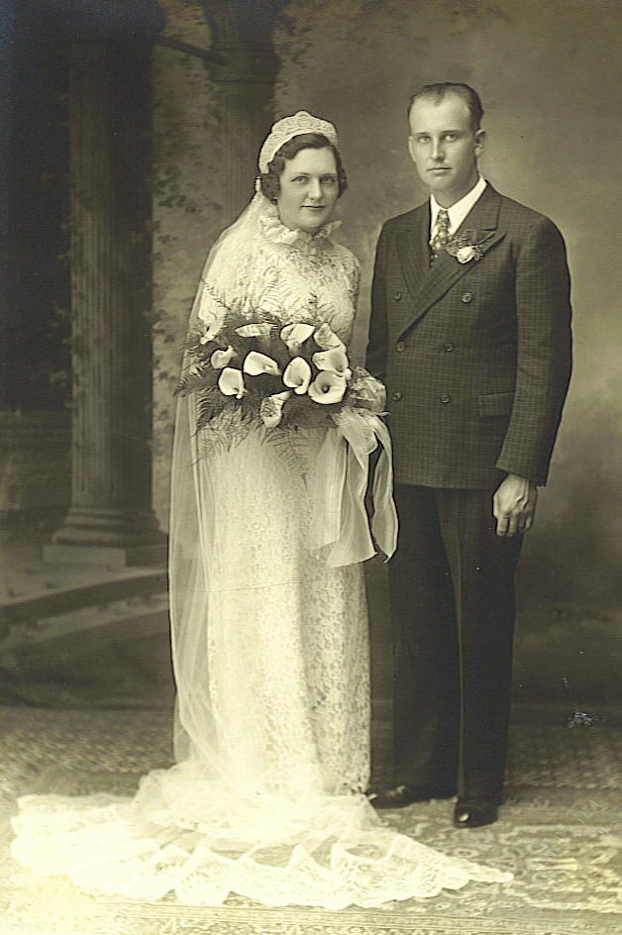
July 4, 1938*Feb. 26, 2003
5.3. Jean Ortmeier
Nov. 15, 1940*
5.4. Nancy Ortmeier
Mar. 1, 1944*
5.5. Judy Ortmeier
Feb. 11, 1946*Apr. 3, 2009
5.6. Thomas Ortmeier
Mar. 15, 1950*
5.7. Dan Ortmeier
Apr. 15, 1952*
5.8. Mary Ann Ortmeier
Feb. 23, 1956*
5.9. Randy Ortmeier
Apr. 3, 1960* Wenzel & Rose Marie Ortmeier, May 12, 1936
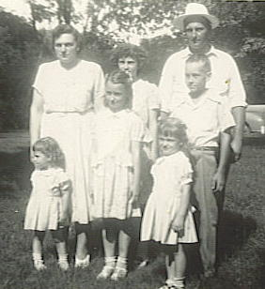

And family, ca. 1948
________________________________________________________________________
Anton Ortmeier, 1798; Ferdinand Ortmeier, 1834; 3.5 Herman Ortmeier, 1868;
4.8 Wenzel Ortmeier, 1910

5.1. Betty Ortmeier m. 06/18/1957 David Kreikemeier
Feb. 22, 1937* West Point, NE Oct. 7, 1934* West Point, NE
6.1. William Joseph Kreikemeier (Bill)
Dec. 8, 1958*Aug. 9, 1974
6.2. Lori Kreikemeier
July 4, 1960*
6.3. Jean Kreikemeier
Mar. 27, 1962*
6.4. Alan Gerard Kreikemeier
Dec. 14, 1963*
6.5. Dean David Kreikemeier
Mar. 28, 1965*
6.6. Joseph Alois Kreikemeier
Dec. 21, 1966*
6.7. Jim Kreikemeier
Aug. 15, 1968*
6.8. Jill Kreikemeier
Apr. 22, 1972*
________________________________________________________________________
Anton Ortmeier, 1798; Ferdinand Ortmeier, 1834; 3.5 Herman Ortmeier, 1868;
4.8 Wenzel Ortmeier, 1910; 5.1 Betty Ortmeier Kreikemeier, 1937
6.1. William Joseph Kreikemeier (Bill)
Dec. 8, 1958*Aug. 9, 1974
Buried at Roselawn Cemetery, Fort Collins, CO
6.2. Lori Kreikemeier m./div. Michael Johnson
July 4, 1960* Fort Collins, CO
7.1. Monika Rae Johnson
Jan. 17, 1989*
7.2. Kendra Leigh Johnson
Apr. 30, 1990*
7.3. Shannon Nicole Johnson
June 11, 1992*
7.4. Sean Johnson
July 6, 1994*
6.3. Jean Kreikemeier m. Terrence Flattery
Mar. 27, 1962* Fort Collins, CO May 24, 1955* Fort Dodge, IA
7.1. Jonathan Flattery
May 26, 1991*
7.2. Anthony Flattery
Sept. 13, 1992*
7.3. David Flattery
May 6, 1995*
7.4. Robert Flattery
July 5, 1997*
6.4. Alan Gerard Kreikemeier m. Nora Bensko
Dec. 14, 1963* Fort Collins, CO May 22, 1962* Burbank, CO
7.1. Tru William Kreikemeier
Oct. 22, 2004*
7.2. Lily Quian Kreikemeier
Apr. 23, 2007*
6.5. Dean David Kreikemeier m.08/13/1988 Dawn Lance
Mar. 28, 1965* Fort Collins, CO Mar. 2, 1965* Oklahoma City, OK
7.1. Jamie Lynn Kreikemeier
Aug. 19, 1991*
6.6. Joseph Alois Kreikemeier
Dec. 21, 1966* Fort Collins, CO
6.7. Jim Kreikemeier
Aug. 15, 1968* Fort Collins, CO
6.8. Jill Kreikemeier m. Lawrence Boyle
Apr. 22, 1972* Fort Collins, CO June 5, 1970* Sioux City, IA
7.1. John William Boyle
Apr. 14, 2000*
7.2. Daniel Walter Boyle
Aug. 3, 2001*
7.3. Michael Patrick Boyle
Sept. 19, 2003
7.4. Kiera Nicole Boyle
Apr. 21, 2005*
7.5. James Boyle
Jan. 22, 2007*
________________________________________________________________________
Anton Ortmeier, 1798; Ferdinand Ortmeier, 1834; 3.5 Herman Ortmeier, 1868;
4.8 Wenzel Ortmeier, 1910
5.2. Jim Ortmeier m. 04/23/1960 Clairetta Uher
July 4, 1938, West Point, NE*Feb. 26, 2003 May 7, 1941, Dodge, NE*Aug. 3, 2003
Both are buried at St. Michael’s Cemetery, West Point, NE
Adopted Children:
6.1. Todd Ortmeier
Oct. 24, 1965*
6.2. Troy Ortmeier
Jan. 17, 1968*
________________________________________________________________________
Anton Ortmeier, 1798; Ferdinand Ortmeier, 1834; 3.5 Herman Ortmeier, 1868;
4.8 Wenzel Ortmeier, 1910; 5.2 Jim Ortmeier, 1938
6.1. Todd Ortmeier
Oct. 24, 1965* Denver, CO
6.2. Troy Ortmeier m. Holly Vogaltance
Jan. 17, 1968* Omaha, NE
7.1. Brent M. Ortmeier Melissa Joyce
Jan. 7, 1987*
8.1. Matthew James
Feb. 23, 2011*
7.2. Shelby Ortmeier
July 25, 1991*
7.3. Jordan M. Ortmeier
June 12, 1994*
(Troy) m. 06/18/2002 Kristy Marie Evert
Dec. 15, 1978*
7.4. Haley A. Ortmeier
Mar. 25, 2003*
7.5. Blake J. Ortmeier
May 15, 2004*
7.6. Jaycee M. Ortmeier
Feb. 7, 2006
________________________________________________________________________
Anton Ortmeier, 1798; Ferdinand Ortmeier, 1834; 3.5 Herman Ortmeier, 1868;
4.8 Wenzel Ortmeier, 1910
5.3. Jean Ortmeier m. 11/27/1965 Don McCarthy
Nov. 15, 1940* West Point, NE Sept. 12, 1936* Spalding, NE
Adopted children:
6.1. Susan McCarthy
Aug. 4, 1970*
6.2. Edward McCarthy
Mar. 10, 1974*
________________________________________________________________________
Anton Ortmeier, 1798; Ferdinand Ortmeier, 1834; 3.5 Herman Ortmeier, 1868;
4.8 Wenzel Ortmeier, 1910; Jean Ortmeier McCarthy, 1940
6.1. Susan McCarthy m. Kenneth Pfeifer
Aug. 4, 1970* Omaha, NE July 29, 1966* Spalding, NE
7.1. Brittany Rose Pfeifer
July 2, 1991*
7.2. Leslie Rachelle Pfeifer
May 18, 1993*
7.3. Joshua Lee Pfeifer
Mar. 7, 1997*
7.4. Dylan Andrew Pfeifer
Feb. 28, 2003*
6.2. Edward McCarthy
Mar. 10, 1974*
________________________________________________________________________
Anton Ortmeier, 1798; Ferdinand Ortmeier, 1834; 3.5 Herman Ortmeier, 1868;
4.8 Wenzel Ortmeier, 1910
5.4. Nancy Ortmeier m. 09/17/1966 David Boyle
Mar. 1, 1944* West Point, NE Sept. 15, 1941* Sioux City, IA
6.1. Debra Sue Boyle
Aug. 16, 1967*
6.2. Brian David Boyle
Oct. 1, 1968*
6.3. Steven Joseph Boyle
May 26, 1970*
________________________________________________________________________
Anton Ortmeier, 1798; Ferdinand Ortmeier, 1834; 3.5 Herman Ortmeier, 1868;
4.8 Wenzel Ortmeier, 1910; 5.4 Nancy Ortmeier Boyle, 1944
6.1. Debra Sue Boyle m. Oct. 6, 1990 Martin Sabo
Aug. 16, 1967* Omaha, NE Nov. 12, 1966* Chicago, IL
7.1. Christian David Sabo
May 30, 1993*
7.2. Emily Sabo
Oct. 9, 1996*
7.3. Mollie Sabo
June 12, 1999*
6.2. Brian David Boyle m. 07/17/1993 Lisa Lynn Lawrence
Oct. 1, 1968* Creighton, NE Dec. 2, 1971* Chicago, IL
7.1. Margaret Lynn Boyle
Dec. 9, 1998*
7.2. Andrew Boyle
Aug. 29, 2001*
7.3. Claire Boyle
Dec. 14, 2004*
7.4. Elizabeth Boyle
July 25, 2008*
6.3. Steven Joseph Boyle
May 26, 1970* Creighton, NE
________________________________________________________________________
Anton Ortmeier, 1798; Ferdinand Ortmeier, 1834; 3.5 Herman Ortmeier, 1868;
4.8 Wenzel Ortmeier, 1910
5.5. Judy Ortmeier-Sindelar m. 07/11/1964 – div. Richard Strehle
Feb. 11, 1946, West Point, NE*Apr. 3, 2009 Dec. 17, 1942*
Buried at St. Joseph Cemetery, Dodge, NE
6.1. Kevin Strehle
July 18, 1965*
6.2. Beth Strehle
May 8, 1967*
________________________________________________________________________
Anton Ortmeier, 1798; Ferdinand Ortmeier, 1834; 3.5 Herman Ortmeier, 1868;
4.8 Wenzel Ortmeier, 1910; 5.5 Judy Ortmeier-Sindelar, 1946
6.1. Kevin Strehle m. Tracy Johnson
July 18, 1965* West Point, NE May 1, 1968*
7.1. Maxim Strehle
Aug. 20, 1998*
7.2. Bennett Strehle
Aug. 30, 2001*
7.3. Willem Strehle
Mar. 10, 2005*
7.4. Katie Ann Strehle
6.2. Beth Strehle m. Thomas Murray
May 8, 1967* West Point, NE Dec. 19, 1945* Valparaiso, IN

Stepchildren:
7.1. Thomas S. Murray
Sept. 6, 1966*
(Judy) m. 04/09/1988 Leroy Alexander
m. Dan Sindelar
June 18, 1949*
_______________________________________________________________________
Anton Ortmeier, 1798; Ferdinand Ortmeier, 1834; 3.5 Herman Ortmeier, 1868;
4.8 Wenzel Ortmeier, 1910
5.6. Thomas Ortmeier m. 08/07/1970 Jane Mahlberg
Mar. 15, 1950* West Point, NE Sept. 3, 1951* West Point, NE
6.1. Michael Thomas Ortmeier
Dec. 30, 1970*
6.2. Erin Rose Ortmeier
June 26, 1984*
________________________________________________________________________
Anton Ortmeier, 1798; Ferdinand Ortmeier, 1834; 3.5 Herman Ortmeier, 1868;
4.8 Wenzel Ortmeier, 1910; 5.6 Thomas Ortmeier, 1950
6.1. Michael Thomas Ortmeier m.09/20/1998 Julie Davis
Dec. 30, 1970* Omaha, NE Apr. 15, 1969* Napa, CA
7.1. Benjamin Michael Ortmeier
Jan. 22, 2000*
7.2. Andrew William Ortmeier
Feb. 13, 2004*
6.2. Erin Rose Ortmeier
June 26, 1984* Fort Collins, CO
________________________________________________________________________
Anton Ortmeier, 1798; Ferdinand Ortmeier, 1834; 3.5 Herman Ortmeier, 1868;
4.8 Wenzel Ortmeier, 1910
5.7. Dan Ortmeier m. 05/1992 Cherese
Apr. 15, 1952* West Point, NE
6.1. Chantea Ortmeier
________________________________________________________________________
Anton Ortmeier, 1798; Ferdinand Ortmeier, 1834; 3.5 Herman Ortmeier, 1868;
4.8 Wenzel Ortmeier, 1910
5.8. Mary Ann Ortmeier m. 10/10/1981 Chuck Hackenmiller
Feb. 23, 1956* West Point, NE Aug. 21, 1954* Osage, IA
6.1. Ryan Joseph Hackenmiller
Mar. 11, 1983*
6.2. Lauren Hackenmiller
June 29, 1989*

6.3. Emily Ann Hackenmiller
Apr. 5, 1993*
________________________________________________________________________
Anton Ortmeier, 1798; Ferdinand Ortmeier, 1834; 3.5 Herman Ortmeier, 1868;
4.8 Wenzel Ortmeier, 1910; 5.8 Mary Ann Ortmeier Hackenmiller, 1956
6.1. Ryan Joseph Hackenmiller
Mar. 11, 1983*
6.2. Lauren Hackenmiller
June 29, 1989*
6.3. Emily Ann Hackenmiller
Apr. 5, 1993*
________________________________________________________________________
Anton Ortmeier, 1798; Ferdinand Ortmeier, 1834; 3.5 Herman Ortmeier, 1868;
4.8 Wenzel Ortmeier, 1910
5.9. Randy Ortmeier m. 07/07/1984 LuAnn Belsky
Apr. 3, 1960* West Point, NE Aug. 6, 1962* West Point, NE
6.1. Lindsay Marie Ortmeier
Feb. 26, 1987*
6.2. Katie Elizabeth Ortmeier
June 12, 1990*
________________________________________________________________________
Anton Ortmeier, 1798; Ferdinand Ortmeier, 1834; 3.5 Herman Ortmeier, 1868;
4.8 Wenzel Ortmeier, 1910; 5.9 Randy Ortmeier, 1960
6.1. Lindsay Marie Ortmeier
Feb. 26, 1987* Fremont, NE
6.2. Katie Elizabeth Ortmeier
June 12, 1990* Fremont, NE

Ida Ortmeier and Clement Peatrowsky
________________________________________________________________________________________________________________________________________________
Anton Ortmeier, 1798; Ferdinand Ortmeier, 1834; 3.5 Herman Ortmeier, 1868
4.9. Ida Mary Ortmeier m. 01/12/1932 Clement Peatrowsky
May 24, 1912* Feb. 9, 1907*Oct. 1, 1989
Occupation: Retired Buried at Roselawn Cemetery, Fort Collins, CO

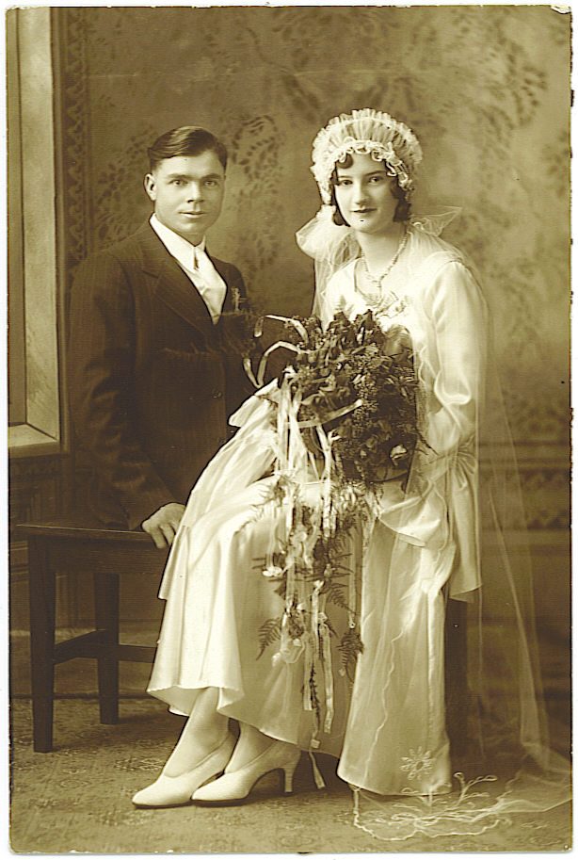
5.1. Leonard Peatrowsky
Aug. 29, 1932*
5.2. Lorraine Peatrowsky
Oct. 23, 1934*
5.3. Darlene Peatrowsky
July 13, 1939*
5.4. Norma Peatrowsky
Nov. 26, 1942*
5.5. Larry Clement Peatrowsky
Apr. 3, 1946*Sept. 2, 1993
5.6. Joan Marie Peatrowsky
July 29, 1949*
5.7. Elaine Peatrowsky
June 23, 1952* Clem & Ida Peatrowsky, Jan. 12, 1932

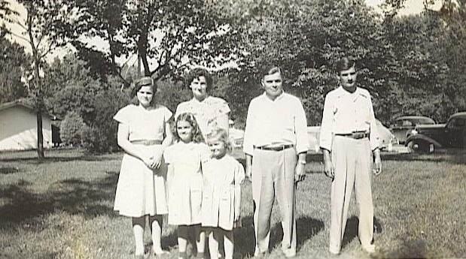

And family, ca. 1948

____________________________________________________________________
Anton Ortmeier, 1798; Ferdinand Ortmeier, 1834; 3.5 Herman Ortmeier, 1868;
4.9 Ida Ortmeier Peatrowsky, 1912
5.1. Leonard Peatrowsky m. 02/19/1955 Imelda Ann Kreikemeier
Aug. 29, 1932* West Point, NE Feb. 25, 1934* West Point, NE
6.1. Bonnie Peatrowsky
Nov. 13, 1955*Dec. 11, 2001
6.2. Daniel Lee Peatrowsky
Nov. 3, 1956*
6.3. James Michael Peatrowsky
Feb. 2, 1958*

6.4. Mary Jean Peatrowsky
May 11, 1959*
6.5. Lori Ann Peatrowsky
Oct. 9, 1961*
6.6. David Peatrowsky
Oct. 29, 1963*
________________________________________________________________________
Anton Ortmeier, 1798; Ferdinand Ortmeier, 1834; 3.5 Herman Ortmeier, 1868;
4.9 Ida Ortmeier Peatrowsky, 1912; 5.1 Leonard Peatrowsky, 1932
6.1. Bonnie Peatrowsky m. 08/10/1985 John Krupka
Nov. 13, 1955, West Point, NE*Dec. 11, 2001
Buried at Roselawn Cemetery, Fort Collins, CO
6.2. Daniel Lee Peatrowsky m. 04/14/1979 Deborah Vaughn
Nov. 3, 1956* Dec. 18, 1951*
7.1. Daniel Kemper Peatrowsky
Oct. 25, 1979*
8.1. Kemper Peatrowsky
July 28, 2003*
8.2. Baby boy
2010*2010 (two weeks)
7.2. Alexandria Peatrowsky
June 2, 1984*
6.3. James Michael Peatrowsky m. 05/23/1980 Angelika Laest
Feb. 2, 1958* Fort Collins, CO
7.1. Shauna Peatrowsky
Dec. 15, 1983*
7.2. Mitchel Peatrowsky
July 17, 1988*
7.3. Andrew Peatrowsky
Dec. 26, 1989*
7.4. Kimberly Peatrowsky
Aug. 16, 1992*
7.5. John Philip Peatrowsky
June 4, 1955*
6.4. Mary Jean Peatrowsky m. 11/18/1978 Steve Griffin
May 11, 1959* Fort Collins, CO May 24, 1957* Greeley, CO
7.1. Zachary Edward Griffin
July 31, 1991*
7.2. Skylar Griffin
Mar. 10, 1998*
6.5. Lori Ann Peatrowsky m. 08/12/1984 Peter Sulmeisters
Oct. 9, 1961* West Point, NE Mar. 4, 1960* Denver, CO
7.1. Jessica Sulmeisters
May 23, 1989*
6.6. David Peatrowsky m. 12/31/1993 Kathy Backer
Oct. 29, 1963* Fort Collins, CO Sept. 18, 1953* Loveland, CO
7.1. Doyle Backer
Nov. 26, 1973*
7.2. Sawyer Peatrowsky
Oct. 12, 1994*
________________________________________________________________________
Anton Ortmeier, 1798; Ferdinand Ortmeier, 1834; 3.5 Herman Ortmeier, 1868;
4.9 Ida Ortmeier Peatrowsky, 1912
5.2. Lorraine Peatrowsky m. 04/03/1956 Alvin Hunke
Oct. 23, 1934* West Point, NE Dec. 9, 1934* West Point, NE
6.1. Susan Kay Hunke
Jan. 31, 1957*
6.2. Gary Lee Hunke
Nov. 18, 1958*
6.3. Diane Hunke
Nov. 19, 1959*
________________________________________________________________________
Anton Ortmeier, 1798; Ferdinand Ortmeier, 1834; 3.5 Herman Ortmeier, 1868;
4.9 Ida Ortmeier Peatrowsky, 1912; 5.2 Lorraine Peatrowsky Hunke, 1934
6.1. Susan Kay Hunke m. 05/05/1979 Luis Cardona
Jan. 31, 1957* West Point, NE May 17, 1952* Sidney, NE
Step Children:
7.1. Christina Lisa Cardona
Nov. 23, 1972*
6.2. Gary Lee Hunke m. 06/29/1982 /div. 2009 Robin Ferro
Nov. 18, 1958* Fort Collins, CO May 17, 1961* New Jersey
7.1. Orion Chase Hunke m. 07/24/2004 Keri JeneanneVallely
Oct. 15, 1982* Nov. 3, 1982*
8.1. Sutter Emery Hunke
Mar. 7, 2006*
8.2. Addison Avery Hunke
May 22, 2007*
8.3. Ollie Skylar Hunke
Oct. 13, 2009*
7.2. Leah Hunke
Aug. 15, 1987*
7.3. Jordan Hunke
July 26, 1989*
6.3. Diane Hunke m. 02/14/1979 Mark Matthews
Nov. 19, 1959* West Point, NE Jan. 4, 1957* Tacoma, WA
7.1. Naomi Matthews m. 06/11/2005 James Gibbons
Nov. 16, 1980* Fort Collins, CO Apr. 27, 1975*
8.1. Jackson Dean Gibbons
Apr. 19, 2007*
7.2. Joseph Nathaniel Matthews m. 01/10/2009 Chandy Sue Gardner
Jan. 26, 1983* Sept. 23, 1978*

8.1. Colton Dean Matthews
May 10, 2010*
________________________________________________________________________
Anton Ortmeier, 1798; Ferdinand Ortmeier, 1834; 3.5 Herman Ortmeier, 1868;
4.9 Ida Ortmeier Peatrowsky, 1912
5.3. Darlene Peatrowsky m. 02/16/1959 Edward Kiefer
July 13, 1939* West Point, NE Nov. 15, 1928* Illinois
6.1. Karen Kiefer
Nov. 19, 1958*May 19, 2011
6.2. Rita Kiefer
Sept. 28, 1959*
6.3. Michael Kiefer
Apr. 10, 1967*
________________________________________________________________________
Anton Ortmeier, 1798; Ferdinand Ortmeier, 1834; 3.5 Herman Ortmeier, 1868;
4.9 Ida Ortmeier Peatrowsky, 1912; 5.3 Darlene Peatrowky Kiefer, 1939
6.1. Karen Kiefer m. 09/25/1982 Bill Wade
Nov. 19, 1958, Fort Collins, CO*May 19, 2011
Cremated
(Karen) m.10/19/1985 Tom Kraft
Feb. 9, 1955* Kansas City, MO
7.1. Rebecca Kraft m.05/07/2009 Wayne Mitschele
Aug. 4, 1986* Feb. 16, 1983* Springfield, MO
6.2. Rita Kiefer m. 07/10/1993 James Webster
Sept. 28, 1959* Fort Collins, CO Aug. 11, 1960* Fort Collins, CO
7.1. Jessica Ann Webster m. 10/01/2005 Jonathan Adams
Mar. 10, 1981* Nov. 25, 1980*
6.3. Michael Kiefer
Apr. 10, 1967* Greeley, CO
________________________________________________________________________
Anton Ortmeier, 1798; Ferdinand Ortmeier, 1834; 3.5 Herman Ortmeier, 1868;
4.9 Ida Ortmeier Peatrowsky, 1912
5.4. Norma Peatrowsky m. 06/10/1961 – div. Frank Console
Nov. 26, 1942* West Point, NE Oct. 12, 1941*
6.1. Tina Ann Console
June 1, 1962*
6.2. Carla Jean Console
Oct. 9, 1966*
6.3. Frances Console
May 26, 1974*
________________________________________________________________________
Anton Ortmeier, 1798; Ferdinand Ortmeier, 1834; 3.5 Herman Ortmeier, 1868;
4.9 Ida Ortmeier Peatrowsky, 1912; 5.4 Norma Peatrowky Console, 1942
6.1. Tina Ann Console
June 1, 1962* Jamaica, NY

6.2. Karla Jean Console m. 07/03/1987 Joseph Francis Abbate
Oct. 9, 1966* Long Island, New York July 31, 1964* New York
7.1. Anthony Joseph Abbate
Mar. 3, 1989*
7.2. Benito Abbate
Nov. 26, 1996*
7.3. Nico Abbate
July 31, 1994*
7.4. Gabriella Abbate
June 8, 2001*
6.3. Frances Console m. Marc Poppe
May 26, 1974* Glen Cove, NY Apr. 11, 1970* New York
7.1. Maya Rae Poppe
July 7, 2008*
________________________________________________________________________
Anton Ortmeier, 1798; Ferdinand Ortmeier, 1834; 3.5 Herman Ortmeier, 1868;
4.9 Ida Ortmeier Peatrowsky, 1912
5.5. Larry Clement Peatrowsky m. 07/26/1966 Patricia Wilson
Apr. 3, 1946, West Point, NE*Sept. 2, 1993 Aug. 3, 1948* Salina, KS
Buried at Santa Ana Cemetery, Santa Ana, CA.
6.1. Juli Ann Peatrowsky
Aug. 10, 1969*
6.2. Robert Peatrowsky
Dec. 15, 1970*
________________________________________________________________________
Anton Ortmeier, 1798; Ferdinand Ortmeier, 1834; 3.5 Herman Ortmeier, 1868;
4.9 Ida Ortmeier Peatrowsky, 1912; 5.5 Larry Peatrowsky, 1946
6.1. Juli Ann Peatrowsky m. Justin Sweet
Aug. 10, 1969* Orange, CA Apr. 25, 1969* Placentia, CA
7.1. Levi Sweet
Sept. 19, 1994*
7.2. Ethan Sweet
July 16, 1997*
7.3. Ellie Sweet
Oct. 16, 1998*
6.2. Robert Peatrowsky m. Kara
Dec. 15, 1970* Orange, CA Nov. 9, 1970* Orange, CA
7.1. Gracey Allyn Peatrowsky
Feb. 27, 2006*
_______________________________________________________________________
Anton Ortmeier, 1798; Ferdinand Ortmeier, 1834; 3.5 Herman Ortmeier, 1868;
4.9 Ida Ortmeier Peatrowsky, 1912
5.6. Joan Marie Peatrowsky m. 09/14/1968 Jerry D. Graham
July 29, 1949* West Point, NE May 16, 1949* Fort Collins, CO
6.1. Jay Jerry Graham
May 22, 1972*
________________________________________________________________________
Anton Ortmeier, 1798; Ferdinand Ortmeier, 1834; 3.5 Herman Ortmeier, 1868;
4.9 Ida Ortmeier Peatrowsky, 1912; Joan Peatrowsky Graham, 1949
6.1. Jay Jerry Graham
May 22, 1972* Fort Collins, CO
7.1. Jayden Aiyana Graham
July 3, 2003*
________________________________________________________________________
Anton Ortmeier, 1798; Ferdinand Ortmeier, 1834; 3.5 Herman Ortmeier, 1868;
4.9 Ida Ortmeier Peatrowsky, 1912
5.7. Elaine Peatrowsky m. 06/06/1973 – div. David P. Shanahan, Jr.
June 23, 1952* West Point, NE
6.1. Christopher Shanahan
Mar. 13, 1975*
6.2. Matthew Shanahan
May 5, 1977*
________________________________________________________________________
Anton Ortmeier, 1798; Ferdinand Ortmeier, 1834; 3.5 Herman Ortmeier, 1868;
4.9 Ida Ortmeier Peatrowsky, 1912; Elaine Peatrowsky Shanahan, 1952
6.1. Christopher Shanahan
Mar. 13, 1975* in Oakland, CA
6.2. Matthew Shanahan m. div.
May 5, 1977* Travis AF Base, CA
7.1. Stephen Shanahan
Jan. 3, 1995*
7.2. Sierra Shanahan
Feb. 24, 2000*

John Ortmeier and Marcella Vitek
________________________________________________________________________
________________________________________________________________________
Anton Ortmeier, 1798; Ferdinand Ortmeier, 1834; 3.5 Herman Ortmeier, 1868
4.10. John Ortmeier m. 01/07/1936 Marcella Vitek
Feb. 28, 1916, West Point, NE* July 6, 1915, Dodge, NE*
May 27, 1992 Oct. 1, 2002
Both are buried in St. Michael’s Cemetery, West Point, NE
Occupation: Farmer Homemaker
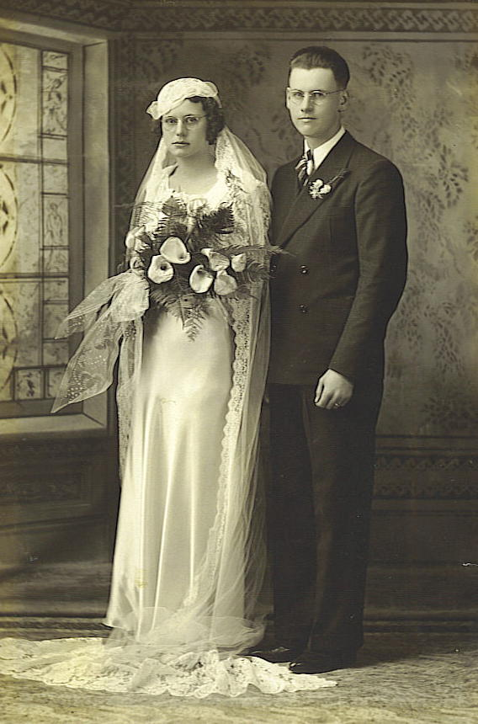
5.1. Janice Ortmeier
Feb. 27, 1938*June 3, 2011
5.2. John Ortmeier, Jr.
July 1, 1943*
5.3. Jonneth Ortmeier
Apr. 1, 1948*
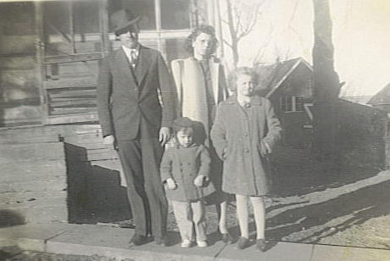

And family, ca. 1946 John & Marcie Ortmeier, Jan. 7, 1936
________________________________________________________________________
Anton Ortmeier, 1798; Ferdinand Ortmeier, 1834; 3.5 Herman Ortmeier, 1868;
4.10 John Ortmeier, 1916
5.1. Janice Ortmeier m. 06/16/1959 Norbert Steffensmeier
Feb. 27, 1938, West Point, NE*June 3, 2011 Sept. 2, 1936* Howells, NE
Buried at Hill Crest Cemetery, Omaha, NE
6.1. Cynthia Marie Steffensmeier
Aug. 5, 1961*
6.2 Constance Joan Steffensmeier
Jan. 23, 1963*
6.3. Colleen Kay Steffensmeier
Dec. 13, 1965*
________________________________________________________________________
Anton Ortmeier, 1798; Ferdinand Ortmeier, 1834; 3.5 Herman Ortmeier, 1868;
4.10 John Ortmeier, 1916; 5.1 Janice Ortmeier Steffensmeier, 1938
6.1. Cynthia Marie Steffensmeier m. 06/05/1982 Chris Yosten
Aug. 5, 1961* June 3, 1962*
7.1 Debra Marie Yosten m. Jeremey Shannon
Oct. 25, 1984*
7.2 Brandon Christopher Yosten
Nov. 29, 1987*

7.3 Brian Anthony Yosten
July 9, 1991*
6.2. Constance Joan Steffensmeier m. Paul F. Malenica
Jan. 23, 1963*West Point, NE Apr. 29, 1959*New Orleans, LA
7.1 Andrew Paul Malenica
Oct. 11, 1993*
6.3. Colleen Kay Steffensmeier m. 03/31/1990 Mark A. Hunter
Dec. 13, 1965*West Point, NE Sept. 9, 1964*Omaha, NE
7.1 David Alan Hunter
Mar. 28, 1995*
7.2 Joseph Anthony Hunter
Mar. 19, 1997*
________________________________________________________________________
Anton Ortmeier, 1798; Ferdinand Ortmeier, 1834; 3.5 Herman Ortmeier, 1868;
4.10 John Ortmeier, 1916
5.2. John H. Ortmeier, Jr. m. 08/20/1963 Geraldine Cerny
July 1, 1943* West Point, NE Feb. 14, 1943*Rogers, NE
6.1. Rhonda Mae Ortmeier
June 14, 1964*Fremont, NE
6.2. Russell John Ortmeier
Nov. 22, 1965*Fremont, NE
6.3. Kevin Joseph Ortmeier
May 21, 1967*Fremont, NE
________________________________________________________________________
Anton Ortmeier, 1798; Ferdinand Ortmeier, 1834; 3.5 Herman Ortmeier, 1868;
4.10 John Ortmeier, 1916; 5.2 John Ortmeier, Jr., 1943
6.1. Rhonda Mae Ortmeier m. 06/13/1990 Gregory Paul Janky
June 14, 1964*Fremont, NE Apr. 18, 1963*St. Paul, NE
7.1. Madison Janky
Oct. 27, 1999*
6.2. Russell John Ortmeier m. Sharon Benne
Nov. 22, 1965*Fremont, NE June, 19, 1997*Fremont, NE 7.1. Austen Ortmeier
Aug. 21, 1996*
7.2. Amanda Ortmeier
Apr. 22, 1999*
6.3. Kevin Joseph Ortmeier m. 12/07/2002 Amy Westermann
May 21, 1967*Fremont, NE Sept. 26, 1971*Omaha, NE
7.1. Sophia Ortmeier
Dec. 6, 2004*
7.2. Ellie Ortmeier
Aug. 11, 2007*

________________________________________________________________________
Anton Ortmeier, 1798; Ferdinand Ortmeier, 1834; 3.5 Herman Ortmeier, 1868;
4.10 John Ortmeier, 1916
5.3. Jonneth Katherine Ortmeier m. 12/13/1969 – div. Darryl Balius
Apr. 1, 1948* West Point, NE
6.1. Suzanne Marie Barker
Nov. 11, 1970*
6.2. Todd Schwartz
Feb. 7, 1961*
6.3. Greg Schwartz
Sept. 20, ----*
6.4. Dawn Schwartz
Jan. 24, 1965*
________________________________________________________________________
Anton Ortmeier, 1798; Ferdinand Ortmeier, 1834; 3.5 Herman Ortmeier, 1868;
4.10 John Ortmeier, 1916; 5.3 Jonneth Ortmeier Schwartz, 1948

(Jonneth) m. 05/30/- Ray Barker
July 25, ----*Dec. 24, 1979
6.1. Suzanne Marie Barker
Nov. 11, 1970*
(Jonneth) m. 07/16/1981 Sam Penni
Aug. 3, ----*
(Jonneth) m. Tom B. Schwartz
Nov. 6, 1932*
6.2. Todd Schwartz m.07/01/1999 Laura Lambert
Feb. 7, 1961* Oct. 21, 1976*
6.3. Greg Schwartz m. Ann
Sept. 20, ----*
7.1. Jennifer Schwartz
Mar. 9, 2000*
7.2. Stephen Schwartz
June 17, 2001*
6.4. Dawn Schwartz m. Quay Richerson
Jan. 24, 1965*
7.1. Jordan Richerson
May 18, 1993*
7.2. Jacob Richerson
Aug. 7, 1995*
7.3. Jared Richerson
Jan. 20, 2000*

Verna Ortmeier and Dale Schneider
________________________________________________________________________________________________________________________________________________
Anton Ortmeier, 1798; Ferdinand Ortmeier, 1834; 3.5 Herman Ortmeier, 1868
4.11. Veronica Ortmeier m. 10/17/1939 Dale Schneider
Nov. 18, 1918* West Point, NE Apr. 28, 1918* Snyder, NE
Aug. 11, 2002 Oct. 13, 1966
Both are buried at Grandview Cemetery, Fort Collins, CO
Occupation: Carpenter & pallet maker for Woodward Governor
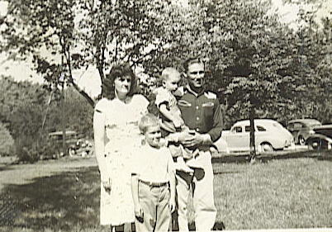
5.1. Ronald Clark Schneider
May 29, 1940*Apr. 20, 2001
5.2. Stanley Dale Schneider
May 9, 1946*
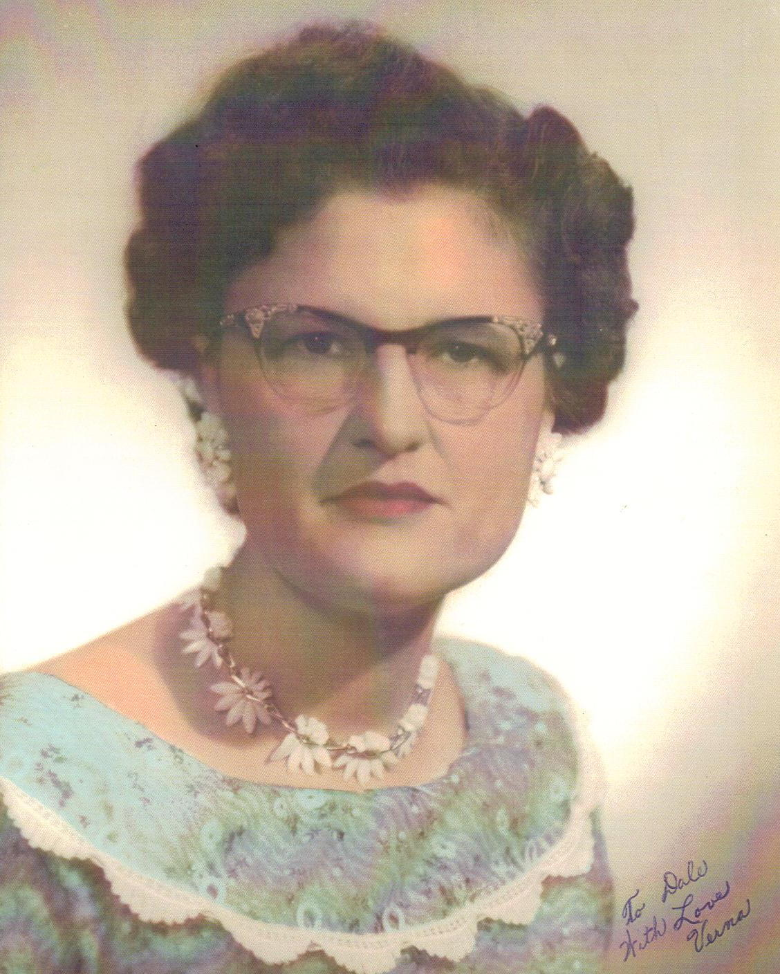
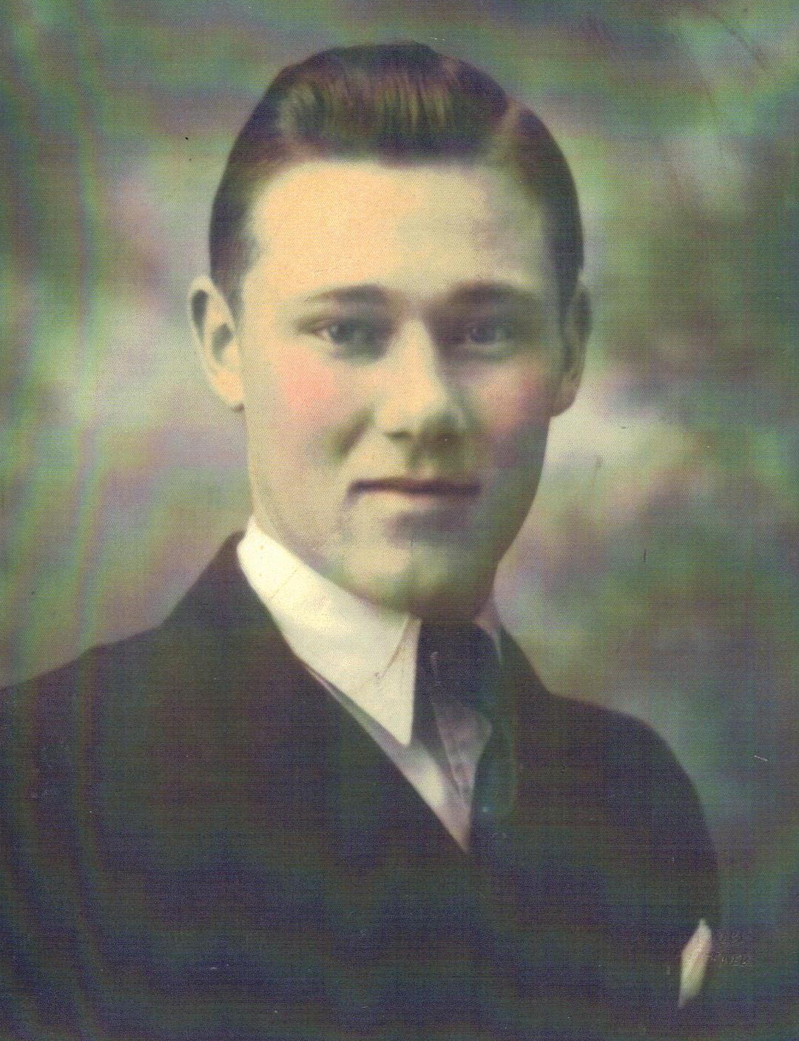

Verna Ortmeier Dale Schneider And family, ca. 1948
________________________________________________________________________
Anton Ortmeier, 1798; Ferdinand Ortmeier, 1834; 3.5Herman Ortmeier, 1868;
4.11 Veronica Ortmeier Schneider, 1918
5.1. Ronald Clark Schneider m. 09/1967 – div. Jane
May 29, 1940* in West Point, NE*Apr. 20, 2001
Cremated
6.1. Deena McBain
Nov. 4, 1974*
________________________________________________________________________
Anton Ortmeier, 1798; Ferdinand Ortmeier, 1834; 3.5Herman Ortmeier, 1868;
4.11 Veronica Ortmeier Schneider, 1918; 5.1 Ronald Schneider, 1940
6.1. Deena McBain
Nov. 4, 1974*
________________________________________________________________________
Anton Ortmeier, 1798; Ferdinand Ortmeier, 1834; 3.5Herman Ortmeier, 1868;
4.11 Veronica Ortmeier Schneider, 1918
5.2. Stanley Dale Schneider m. 06/23/1984 Cara St. John
May 9, 1946* in Fort Collins, CO
6.1. Jason
Dec. 6, 1972*
6.2. Tana
Mar. 14, 1977*
6.1. Dale C. Schneider
Dec. 18, 1984*

________________________________________________________________________
Anton Ortmeier, 1798; Ferdinand Ortmeier, 1834; 3.5Herman Ortmeier, 1868;
4.11 Veronica Ortmeier Schneider, 1918; 5.2 Stanley Schneider, 5.2
Step Children:
6.1. Jason
Dec. 6, 1972*
6.2. Tana
Mar. 14, 1977*
(Stan) m. Sharon
6.1. Dale C. Schneider
Dec. 18, 1984*

